**5. Leisure Activities**

* **I can *describe* pictures of leisure activities.**
* Use leisure activity pictures.
* Describe pictures together in class, then pass them around the room. Use circle practice to have each student explain the picture to the next.
* **I can *tell* which activities I have or have not done.**
* **I can *ask* which activities someone else has or has not done.**
* Brainstorm additional leisure activities. Have students draw pictures.
* Using activity pictures, teach this question and answer sequence:

Have you ever gone camping?

Yes I have. / No I haven’t.

* Have students practice the sequence, either in circle practice or in pairs.
* Encourage students to do this exercise with their conversation partner.
* **I can *talk* about activities that I will do on the weekend.**
* This could be done in conjunction with the grammar section on the future.
* In pairs, have students tell each other what they will do on the weekend. (Having the pictures available as a reference might help.)
* **I can *discuss* various sports, giving my opinion.**
* In small groups, have students look at various pictures of sports, and make statements giving opinions. For example:

I think football is a dangerous sport.

Hockey requires a lot of expensive equipment.

Riding bikes (bicycling, cycling) is very good for you.

Only rich people can afford to play golf.

* **I can *write* a paragraph about a leisure activity that I enjoy.**
* **I can *read* a description of a leisure activity, and write follow-up questions.**
* Ask students to choose a leisure activity to write about.
* Suggest that students write 4-5 sentences including:

What the activity is, who is included, and why they like this activity.

* The teacher may want to take the paragraphs home at this point and correct them, then have students re-write them.
* Have students exchange paragraphs, reading each other’s paragraphs.
* Go around the room and have each student tell what the paragraph he read was about, who wrote it, and give his opinion of it. (Have students give opinions of the author’s ideas, not their English!)

Project: Collect paragraphs about students’ leisure activities. Add pictures if possible.

Leisure Activities

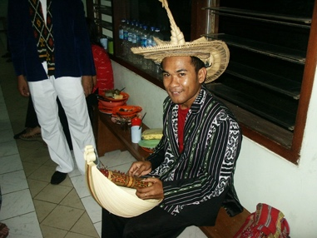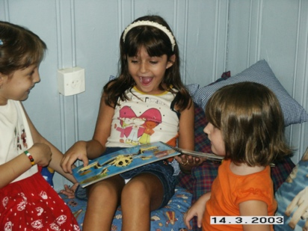

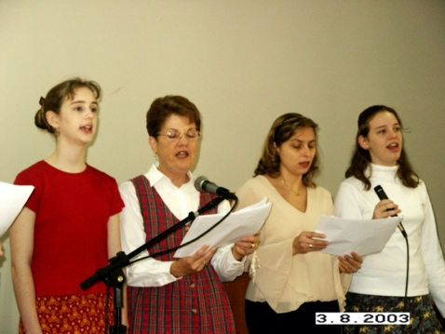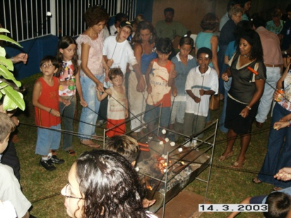Playing an instrument Reading Having a cookout

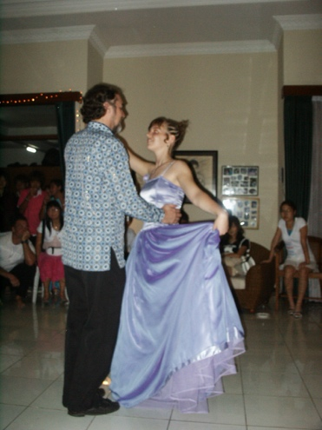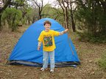

Singing Camping

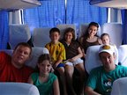

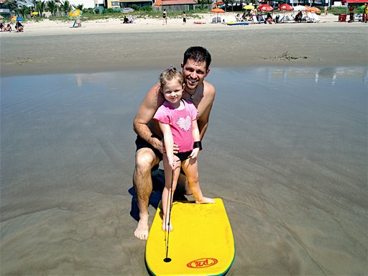 Dancing

Traveling

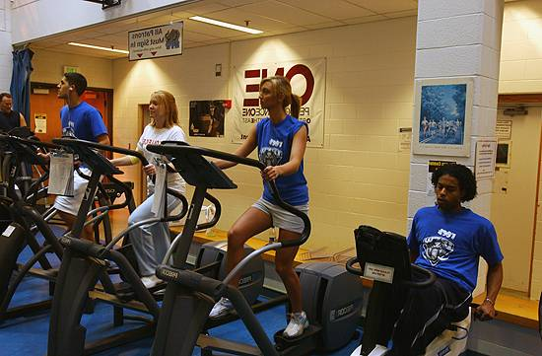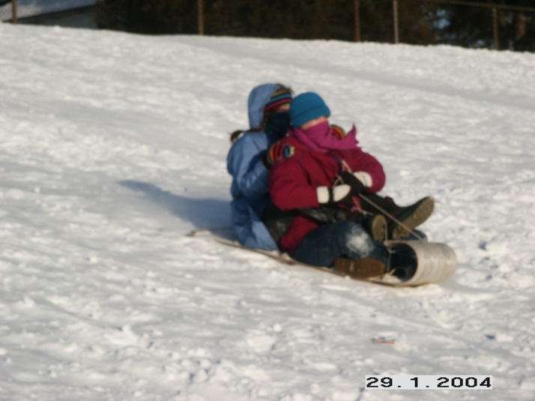 Going to the beach

Working out Sledding

**Sports**

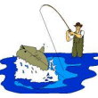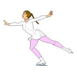

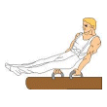

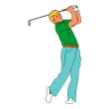

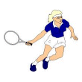

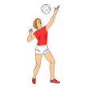

**6. Food**

* **I can *list* my typical daily diet, and *compare* my diet with someone else’s.**
* Have students keep a list of everything they eat for a week, using the form.

(If a week seems too hard, they can just do it for a day.)

* In pairs, have students compare their diets, discussing the differences.
* Students could write five differences, for additional practice, such as:

I eat a big breakfast but Maria doesn’t.

Maria eats a lot of snacks, but I don’t.

* **I can *understand* products and prices in a grocery flyer.**
* Have students look through the flyers, making a list of ten things they would like to buy.
* Have students find ten things that seem expensive.
* Have students find five products that they do not understand (they don’t know what it is, what it’s used for, or don’t understand the price). Have them first ask a classmate for help, then ask the teacher.
* **I can *talk* about my food preferences, and ask questions about someone else’s.**
* **I can *talk* about the food preferences of my family.**
* Have students make a list of their ten favorite foods.
* In pairs, student A asks: “I like chocolate. Do you?” Student B responds. After student A has mentioned each item on his list, they switch roles.
* Do the same activity, only this time writing lists of the food preferences of a family member. For example: “My daughter likes spaghetti. Does yours?”

Note: For this activity, try to pair students who are comparing the same family

member, e.g., a daughter, a husband, etc.

* **I can *read* a recipe and understand ingredients and measurements.**
* Show students a recipe (the one provided or another).
* Discuss measurements and ingredients. Ask some questions, such as: “Tell me three ingredients in this recipe.” “Is this recipe baked?” “Is this a salty or a sweet recipe?”
* If possible, make a sample of the recipe used above, and bring it in for the students to taste.
* **I can *compliment* someone on their cooking.**
* As students taste the sample above, teach them complimentary phrases such as: “This is very good.” “You’re a good cook.” “Can I get the recipe?”
* Have students role-play going to each other’s homes, eating a meal, and complimenting the cook.

Project: Divide the class into two groups. Have one group write up a “Typical Indonesian Diet”. Have the other group create a list of Indonesian food basics, complete with standard prices.

**My Food Diary**

|  |  |  |  |  |
| --- | --- | --- | --- | --- |
|  | **Breakfast** | **Lunch** | **Supper** | **Snacks** |
| **Monday** |  |  |  |  |
| **Tuesday** |  |  |  |  |
| **Wednesday** |  |  |  |  |
| **Thursday** |  |  |  |  |
| **Friday** |  |  |  |  |
| **Saturday** |  |  |  |  |
| **Sunday** |  |  |  |  |

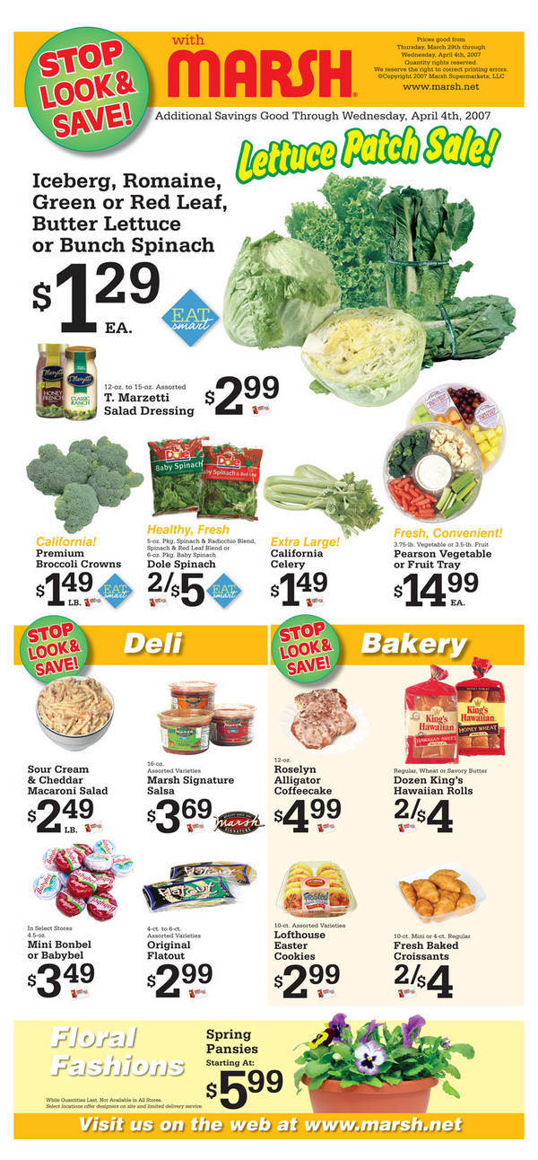



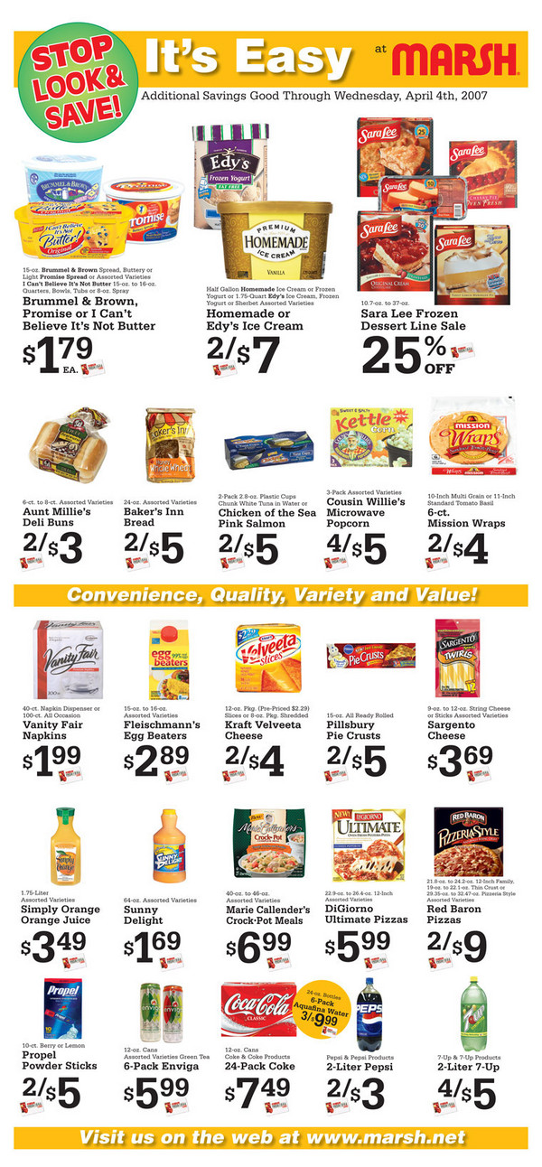

**My Grocery List**

I would like to buy:

1. ______________________________ Price: _____________

2. ______________________________ Price: _____________

3. ______________________________ Price: _____________

4. ______________________________ Price: _____________

5. ______________________________ Price: _____________

6. ______________________________ Price: _____________

7. ______________________________ Price: _____________

8. ______________________________ Price: _____________

9. ______________________________ Price: _____________

10. ______________________________ Price: _____________

These things seem expensive:

1. ______________________________ Price: _____________

2. ______________________________ Price: _____________

3. ______________________________ Price: _____________

4. ______________________________ Price: _____________

5. ______________________________ Price: _____________

6. ______________________________ Price: _____________

7. ______________________________ Price: _____________

8. ______________________________ Price: _____________

9. ______________________________ Price: _____________

10. ______________________________ Price: _____________

I don’t understand this:

1. __________________________________________________________

2. __________________________________________________________

3. __________________________________________________________

4. __________________________________________________________

5. __________________________________________________________

Papaya Spice Muffins

*Ingredients:*

½ cup brown (or white) sugar

½ cup oil

2 eggs

1 ¼ cup mashed papaya

½ cup sliced almonds

2 cups whole wheat (or regular) flour

¼ t. baking powder

1 t. baking soda

½ t. salt

½ t. cinnamon

½ t. ginger

¼ t. nutmeg

¼ t. cloves

*Method:*

Cream sugar and oil. Add eggs and beat until fluffy. Add papaya and nuts. Mix dry ingredients together, then fold into papaya mixture. Fill 12 muffin cups. Bake at 350 degrees F for about 20 minutes.

Measurements and Equivalents

3 teaspoons = 1 tablespoon 1 tablespoon = ½ fluid ounces 1 teaspoon = 5 ml.

4 tablespoons = ¼ cup 1 cup = 8 fluid ounces 1 tablespoon = 15 ml.

5 1/3 tablespoons = 1/3 cup 1 cup = ½ pint 1 cup = 240 ml.

8 tablespoons = ½ cup 2 cups = 1 pint 1 quart = 1 liter

10 2/3 tablespoons = 2/3 cup 4 cups = 1 quart 1 ounce = 28 grams

12 tablespoons = ¾ cup 2 pints = 1 quart 1 pound = 454 grams

16 tablespoons = 1 cup 4 quarts = 1 gallon 2.2 pounds = 1 kilo

Abbreviations

ounce = oz. teaspoon = t

pound = lb. tablespoon = T

quart = qt. cup = c.

gallon = gal.

**7. House and Home**

* **I understand words for kitchen utensils and appliances.**
* Bring in real utensils, or pictures. Teach words, using circle practice or games.
* **I understand words associated with bedrooms and bathrooms.**
* Show students pictures of your bedroom and bathroom. Or, use the worksheet provided. (Answers: bed, pillows, curtains, lamp, blanket; toilet, sink, bathtub, mirror; found in bedroom: closet, dresser, clothes rack; found in bathroom: shower, medicine cabinet, towel rack)
* Have students take turns telling what is in their bedroom and bathroom.
* **I can *read* about a home and answer questions.**
* Give the reading “A Cabin on a Lake” (or substitute a different reading, with similar pictures and descriptions).
* Have students work in pairs to read, then answer the questions together.
* Have students share their answers with the class.
* **I can *describe* my home, including rooms, colors, and furniture.**
* **I can *answer* simple questions about my home.**
* **I can *ask* questions about someone’s home, and *understand* their answers.**
* Explain to students that foreigners coming to Indonesia might need a place to stay. Ask them to imagine that they could “rent” a room in their home for $30 per day. Their task now is to describe their home so that someone would want to stay there.
* Have students write descriptions of the rooms in their homes, bringing in accompanying pictures or drawings.
* If the class is small, have students take turns sharing their descriptions and pictures with the whole class. Have the students ask questions of the presenter.
* At the end of each presentation, ask the class if they would want to stay there, and what the presenter could do to better explain or “show off” their home.
* Throughout this exercise help students understand that what makes a home a nice place to stay is more than comfort and furniture. Good food, interesting activities, and a pleasant atmosphere go a long way!

Project: Collect descriptions of students’ homes, with drawings. Prepare a class “advertisement” showing all the rooms foreigners could rent during their stay in Indonesia.

In the Kitchen

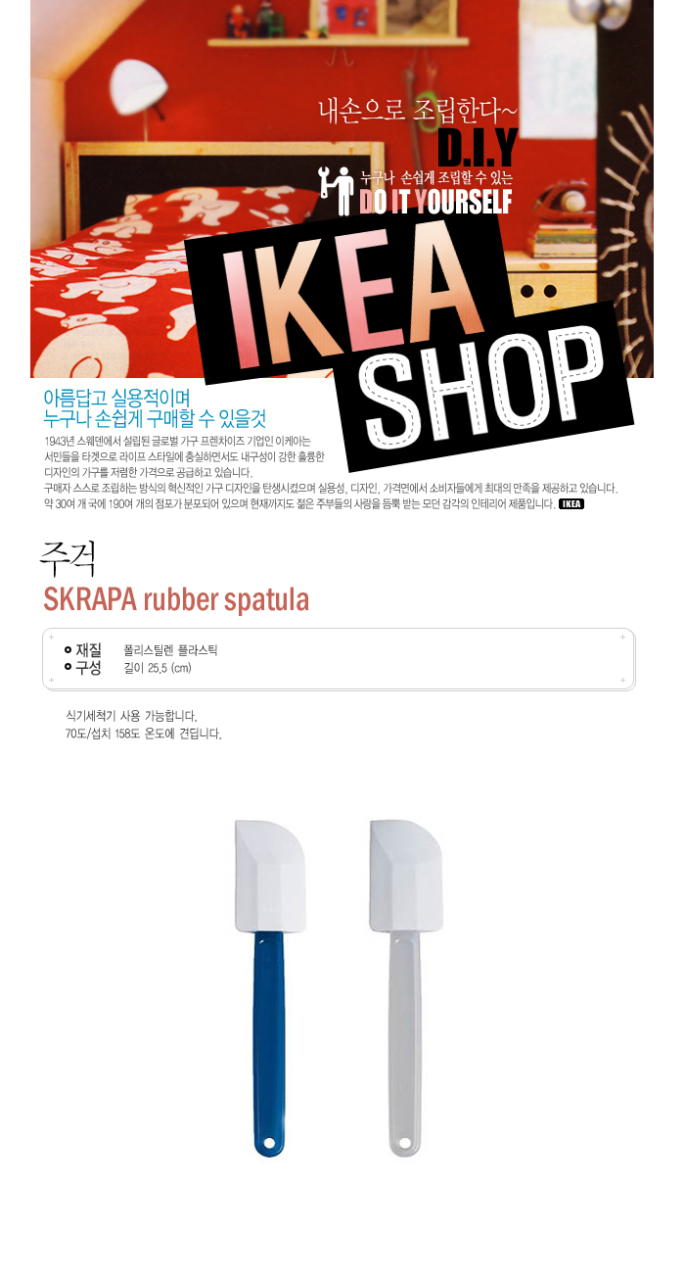

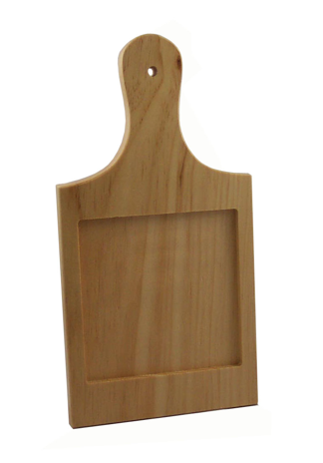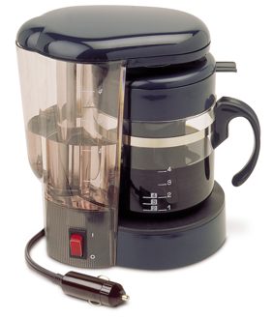

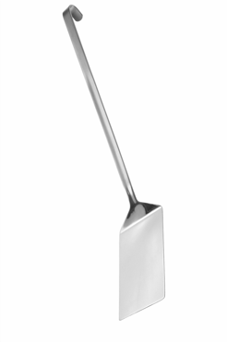

Coffee maker

Cutting board Scraper spatula

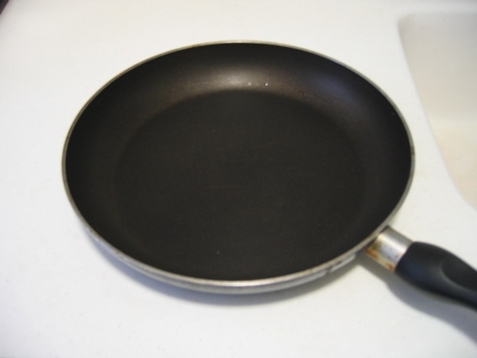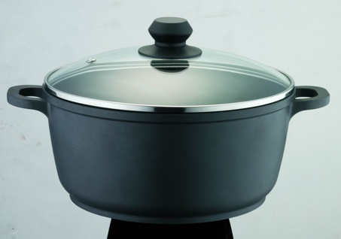

Pot Skillet

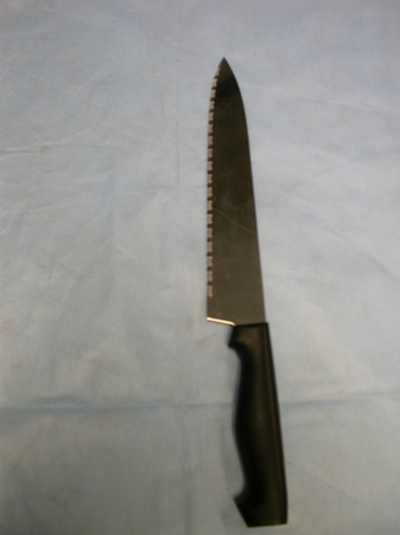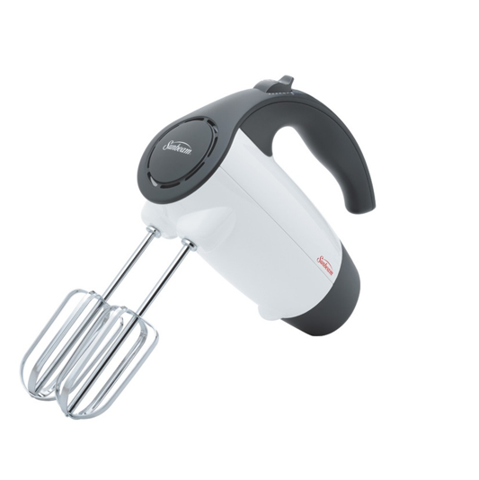

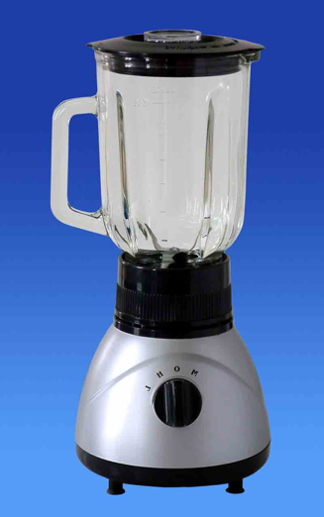

Mixer

Blender Knife

In the Bedroom and Bathroom

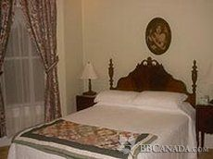

What do you see in the bedroom?

B__ __

P__ __ __ __ __ __

C__ __ __ __ __ __ __

L__ __ __

B__ __ __ __ __ __

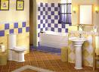

What do you see in the bathroom?

T__ __ __ __ __

S__ __ __

B__ __ __ __ __ __

M__ __ __ __ __

These pictures are missing some things normally found in these rooms. Where would you put….

*closet shower dresser*

*medicine cabinet towel rack clothes rack*

|  |  |
| --- | --- |
| **Bedroom** | **Bathroom** |
|  |  |
|  |  |
|  |  |

A Cabin on a Lake

<http://www.cabinauborddulac.com/index.html>

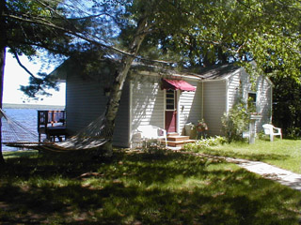

***Welcome to our cabin, located on Portage Lake in Michigan! The cottage overlooks the lake and offers a scenic view of sunrises and sunsets over the water. The cottage offers year round accommodations for up to four people. It is located just 30 feet from the lake. There is great fishing in this area. The water is great for swimming, because it is sandy and shallow for a long distance. The deck has a gas grill for outdoor cooking, and a table and chairs for picnics.***

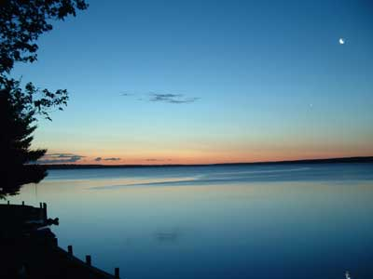

***Summer is beautiful here. Swimming, boating, fishing, golfing, hiking, biking, birdwatching, and many waterfalls are just some of the attractions. There are also many tourist and historic sites to see.***

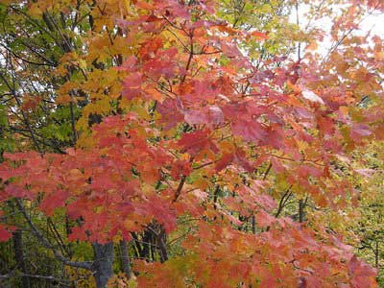

***The Fall has attracted people from all over the world for our colors. The trees are magnificent with the most gorgeous colors ever to be seen. Bird watching and deer hunting are fall attractions in this area.***

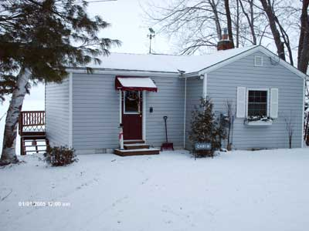

***Winter visitors love the snow! We are close to the ski hills. We also have places to ice skate, indoors and outdoors. The plentiful snow and open areas make it an attraction for snowshoeing and sledding as well.***

The Rooms

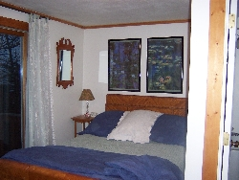

***The bedroom consists of a double bed, a dresser, a desk and chair and a patio door to the deck overlooking the lake.***

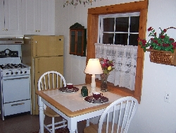

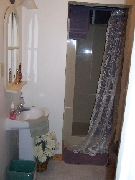***The kitchen consists of a stove, refrigerator, microwave, sink, cupboards, storage, broom, mop, cleaning supplies, coffee maker, toaster, dishes, glassware, pots, pans, silverware, and utensils.***

***The bathroom has a new shower stall, toilet, and sink. It is equipped with towels, soap, shampoo, conditioner and hair dryer.***

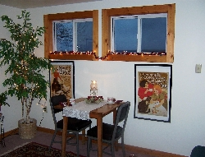

***The living room is equipped with a leather love seat, a twin day bed, a cafe table with two chairs, and TV/VCR combo, with cable, along with several movies to pick from.***

*Questions*

1. Where is the cabin?
2. How many people can stay in the cabin?
3. Is the lake a good place for children to swim? Why?
4. Where can you eat?
5. What activities can you do in the summer?
6. What activities can you do in the fall?
7. What activities can you do in the winter?
8. What does the bedroom have?
9. What does the kitchen have?
10. What does the bathroom have?
11. What does the living room have?
12. Would you like to take a vacation at this cabin?
13. What season would you like to go? Why?

**8. Friends**

* **I can *read* about a friendship, and *answer* questions.**
* Give students the reading “My Best Friend.” Have students look at the picture and answer the pre-reading questions in small groups.
* Have students read the paragraph silently, and answer the follow-up questions individually.
* Have students get back into their groups, and share their answers.
* In pairs, student A describes a friend, student B asks follow-up questions, and student A answers the questions.
* **I can *describe* a friend, including looks, personality, and activities.**
* **I can *answer* questions about my friend.**
* Have each student bring in a picture of a friend.
* Have students take turns going to the front of the class to answer questions about their friend. Classmates should look at the picture, then ask questions about looks, personality and activities.
* **I can *make a polite request.***
* **I can *extend an invitation*.**
* **I can *make an apology*.**
* **I can *initiate a friendly conversation*.**
* Help students understand that speaking politely in a language usually involves using certain phrases that people interpret as being polite. If possible, this could be illustrated by having two teachers act out an impolite dialogue, such as the following:

Ann: I want you to close the window.

Bob: Why?

Ann: I’m cold. Close the window.

Bob: Close it yourself!

* Give students the worksheet “Tasks to Practice Polite Speech”. Have them work in pairs, creating dialogues for each of the situations. Have students act out their dialogues in front of the class.
* In groups, assign students one of the categories: request, invitation, apology, or initiating a conversation. Have each group think of a real situation, in their own lives, where they may need to use this speech function *in English.* Have students create dialogues. Check the dialogues, then have students perform them in front of the class.
* Brainstorm together as a class differences between politeness in English and politeness in Indonesian. Create a chart showing any differences.

Project: Assign two or three students the task of finalizing the chart created (showing differences in politeness) to add to the book for foreigners in Indonesia.

My Best Friend!

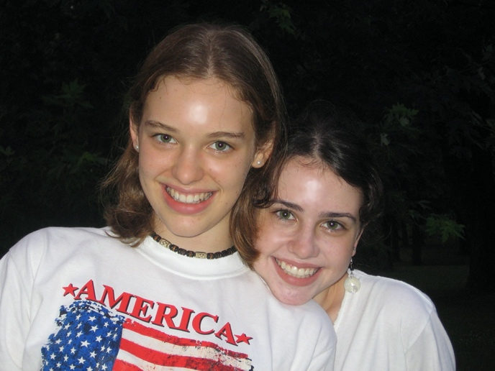

Look at the picture. Do you think these girls are friends? Why?

What do you think they like about each other?

What do you think they do together?

Read the paragraph:

My best friend is my cousin. She is different from me: I’m tall and she’s short; I live in Indonesia while she lives in Brazil; and I am Canadian-American but she is Brazilian-American. But we have a lot in common too. We both are ambitious and we talk a lot about where we will go to college and what we will do when we grow up. We are both adventurous and outgoing. We both have older sisters and we have pet dogs that we love to play with. Most of all, we are both Christians and we both want to serve Christ with our lives.

Were your predictions right?

Is there anything unusual in this friendship?

How are these friends different and alike?

Write about YOUR special friend!

Tasks to Practice Polite Speech

Work with a partner. Read each situation, then create a dialogue, using the suggested phrases.

***Making a request***

Jane has stopped in to visit with Susan. Jane is very thirsty. Also, the fan is too strong for her. What can she say?

Possible phrases to use: I’m sorry to bother you, but could I please have…

Do you mind if I…

Could I please…

Would you mind turning down…

***Extending an invitation***

Bob’s son is playing in a championship soccer game. He wants to invite his friends, Joe and Patty, to come and see the game.

Possible phrases to use: Would you like to…

It would be special for us if you could….

I would like to invite you to…

***Making an apology***

Alan borrowed a book from Maria. He was supposed to bring it to class today to give it back to her, but he forgot. What can he say to her?

Possible phrases to use: I’m very sorry, but I…

I’m sorry for…

I’m sorry that I…

I’m afraid that I…. I’m sorry.

***Initiating a friendly conversation***

1. Bob is waiting for a city bus to arrive. Dave is also waiting. Bob would like to talk to Dave. What can he say?

Possible phrases to use: Hi, do you take this bus a lot?

Boy, this bus is late, isn’t it.

Nice weather we’re having today, isn’t it?

2. Sony is an Indonesian English student. She is at a restaurant, and sees a woman who is a foreigner. She wants to talk to her. What can she say?

Possible phrases to use: Hi, do you mind if I talk with you for a minute?

Sorry to bother you, but I would like to practice my

English.

My name is Sony. May I ask where you’re from?