**1. My Family and Me**

* **I can *fill out* a form, giving personal data.**
* Use the form here and other available forms to give students practice.
* Have students create forms for classmates to fill out.
* Exchange forms, reading about each other. This is a good way for students to get to know one another.
* **I can *understand* personal questions and *respond* with information.**
* **I can *ask* questions about someone else, and *understand* the answers.**
* Have students collect information about their classmates (possibly using the form provided), asking them questions:

What’s your first name?

What’s your last name?

How do you spell it?

When were you born?, etc.

* Encourage students to do this exercise with a conversation partner who is not in their class.

OR

* Have students interview each other in pairs, using the worksheet “write about your friend”.
* **I can *ask* about someone else’s family, and *understand* answers.**
* Create a family tree (the teacher’s is good). Give students the names that go on the family tree. Students must ask questions to place names on the tree. Ex:

S: “Who is Kirsten?”

T: “Kirsten is my sister-in-law.”

Provide explanations as necessary, in order for students to learn vocabulary concerning family relationships. Show pictures of the family.

* Have students bring in pictures of their families. Have students provide the names of family members. Working in pairs, students ask and answer questions until they have re-created each other’s family trees.
* **I can *tell* about my family (physical description, age, personality, hobbies).**
* Do the worksheet “Describing People”
* Optional: Play the game “Who’s Who?”
* Have students write characteristics of a family member on cards. Students read the cards. Classmates must guess, making statements like “I think it’s your mother” or “I think it’s your daughter. If possible, the student shows a picture of the family member afterwards.
* **I can *write* a paragraph about a family activity.**
* **I can *read* a classmate’s paragraph about a family activity.**
* Show pictures about typical family activities.
* Ask each student to choose one of these activities, or a different one, to write about concerning their own families. Have students write 4-5 sentences telling what the activity is, who is included, and why this is a good family activity.
* After teacher correction and re-writing, have students exchange paragraphs, reading each other’s paragraphs.

Project: Collect paragraphs and accompanying pictures from each student, describing typical Indonesian family activities.

Fill out a Form

*Sample Form:*

|  |
| --- |
| Personal Information  Name: _____________________________________________________________  Last name First name Nickname  Date of birth: ________________________________________________________  Marital status (circle one): married single engaged divorced/separated  Names and ages of children: ____________________________________________  ____________________________________________________________________  Address: ____________________________________________________________  Phone number: _____________ Hand phone: _______________________________  Email address: _______________________________________________________  How many years have you studied English? ________________________________  Why do you want to study English? ______________________________________ |

*Your turn!* ***Make a Form!***

1. You are a school director. You need to hire a teacher.
2. You are beginning a support group for parents of children with learning problems. You want some information about everyone in the group.
3. You are planning an English Speech competition for English students. You need an enrollment form.

Get to know your classmates!

*Ask questions to collect this information about your classmates:*

1. Full name: ______________________________________________

Date of birth: ____________________________________________

Place of birth: ___________________________________________

Father’s name: ___________________________________________

Mother’s name: __________________________________________

Current residence: ________________________________________

Phone number: ___________________________________________

2. Full name: ______________________________________________

Date of birth: ____________________________________________

Place of birth: ___________________________________________

Father’s name: ___________________________________________

Mother’s name: __________________________________________

Current residence: ________________________________________

Phone number: ___________________________________________

3. Full name: ______________________________________________

Date of birth: ____________________________________________

Place of birth: ___________________________________________

Father’s name: ___________________________________________

Mother’s name: __________________________________________

Current residence: ________________________________________

Phone number: ___________________________________________

4. Full name: ______________________________________________

Date of birth: ____________________________________________

Place of birth: ___________________________________________

Father’s name: ___________________________________________

Mother’s name: __________________________________________

Current residence: ________________________________________

Phone number: ___________________________________________

**Write about Your Friend!**

1. Write questions.
2. Interview a friend.
3. Write answers.
4. Fill in the blanks to write a paragraph about your friend.

|  |  |  |
| --- | --- | --- |
|  | Question | Answer |
| Name |  |  |
| Country |  |  |
| Age |  |  |
| Family |  |  |
| Job |  |  |

1. Read your paragraph to the class.

My friend is ______________. ______ comes from ___________________. _____ is ________________ years old. ______ has _________________

_____________________________________________________________.

______ job is _________________________________________________.

I like my new _________________!

DESCRIBING PEOPLE

She / he has.... blue / grey / green / brown / black **eyes**

long / short / curly / wavy / straight **hair**

black / brown / blond / red / white / grey **hair**

a mustache / a beard

braces (teeth) / a brace (leg)

She / he is... tall / short

heavy / thin

bald / partially bald

pretty (women) / handsome (men) / attractive

nice / friendly / helpful / funny

She / he wears.... glasses / a gold necklace / a white and navy uniform / a watch

She / he is wearing.... blue pants

a white sweater

gold earrings

black shoes

a red tie

a pink jacket

a watch

PRACTICE! *Fill in the blanks*

My friend John ______________ glasses. He _____________ blue eyes, and short, wavy hair. He ____________ partially bald, and he ________________ a mustache. His hair ________________ white, but his mustache _______________ brown. He_____________ fairly tall, and thin. He _______________ very friendly. He usually _____________ a navy and white uniform, because he works in the military. But today he _______________ a red sweater and black slacks. He _____________________black shoes, and black socks. I think he ________ also _______________ a watch.

PRACTICE!

*Describe a family member. Your classmates will guess who it is!*

She / he has _________________________________________________

______________________________________________________________________________________________________________________

She / he is __________________________________________________

______________________________________________________________________________________________________________________

She / he wears _______________________________________________

______________________________________________________________________________________________________________________

Common Family Activities

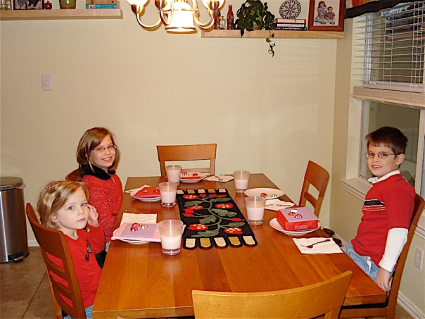

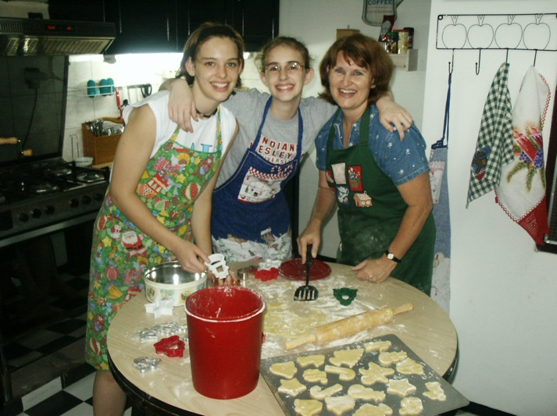

A family meal

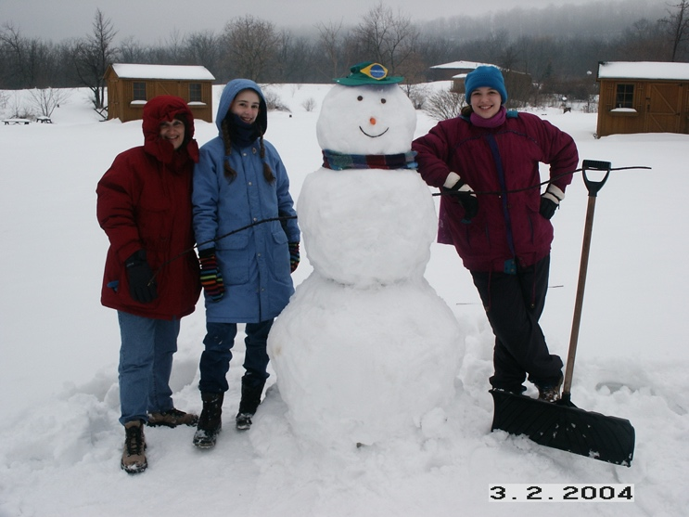 Cooking together

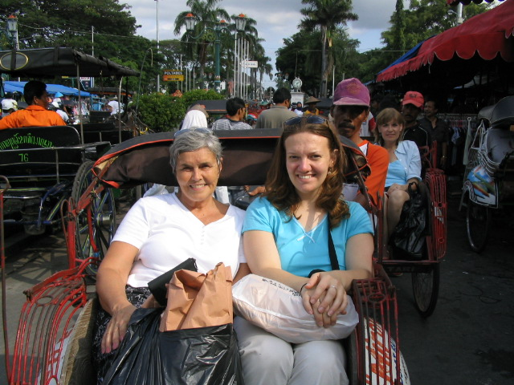

Having fun together

Shopping together!

**2. A Family Event**

* **I can show pictures of a family event and *explain* their meaning.**
* **I can look at a classmate’s pictures and *ask* questions.**
* Show sample pictures of special family events (yours, or the pictures provided). Have students bring in pictures of weddings, new babies, graduations, etc.
* Help them write simple phrases:

This is my graduation from college.

This is my brother’s wedding.

This is my nephew when he was a baby.

* Have students show and explain their pictures in pairs or small groups.
* Have students ask each other questions about their pictures. For example:

Who is this?

When was this?

How old were you?

* **I can *tell* about a family event and *answer* questions.**
* **I can *understand* an event described by someone else, and *answer* questions.**
* Have students choose an event in their lives to tell about. Good events for this activity are things like vacations, trips, visits, or excursions.
* Students should prepare 4 or 5 sentences that they can tell in front of the class, such as:

I went with my family to the beach.

It rained every day.

We played games in the house.

We had fun anyway.

* After a student presentation, have other students ask questions, such as: Where did you go? Who went? Do you go every year?
* **I can *write* a paragraph about a past event.**
* **I can *read* about someone else’s past event, and *write* follow-up questions.**
* Have students choose another event in their lives, preferably involving family. Here are some examples: A mother going back to work after staying home with the kids; An illness in the family; Teaching a child to do something; A move
* Students write the paragraph for homework, teacher checks, and students re-write.
* Exchange paragraphs. After reading the paragraph, students write 3 questions for the author of the paragraph, and return it. The author reads the questions, answering orally.

Project: Collect paragraphs and accompanying pictures from each student, describing typical Indonesian special events.

Special Family Events

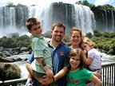

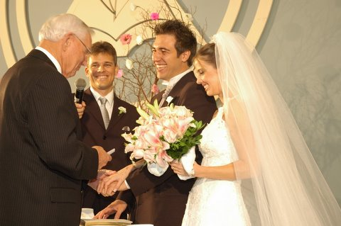 A family vacation

A wedding!

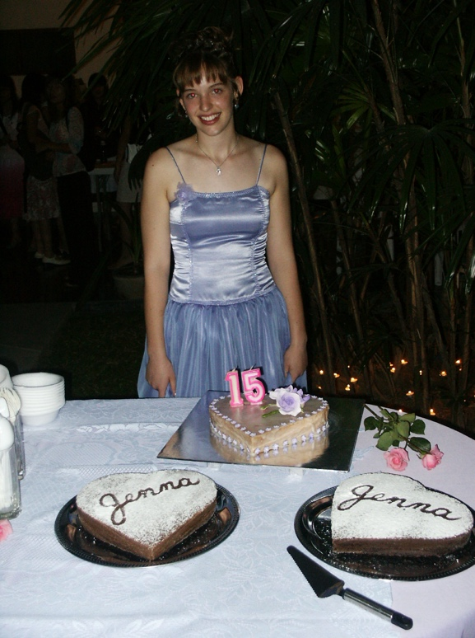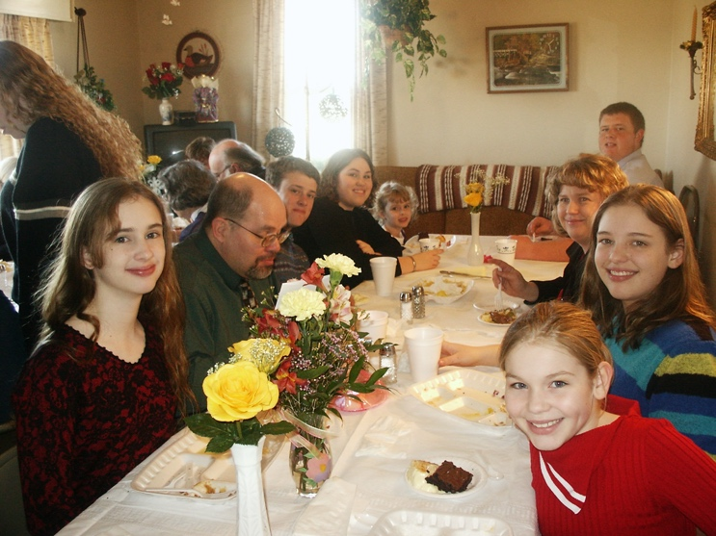

A family reunion

A birthday party

**3. Daily and Weekly Routines**

* **I can *write* my daily or weekly schedule.**
* **I can *read* someone’s schedule, and ask follow-up questions.**
* Provide students with blank forms on which to write daily or weekly schedules.
* Have students exchange schedules, and ask each other questions about them, such as:

Do you walk every day?

When do you go to work?

Note: it might be easier to have students ask each other questions without looking at their schedule. If this is easier or makes more sense, do it that way.

* **I can *describe* my schedule and *answer* questions.**
* Show pictures giving routines. Have students describe their routines, such as:

I get up at 6:00.

I take a shower.

I eat breakfast at 7:00…etc.

* Encourage others to ask the student questions, such as:

What time do you eat supper?

When do go grocery shopping?

* **I can *tell* what I’m doing at different times of the day and week.**
* **I can *ask* what others are doing at different times of the day and week.**
* Ask questions such as:

It’s 10:00 on Tuesday morning. What are you doing?

* Students give their activities using present continuous.
* Repeat this activity in groups or pairs, with students asking the questions.
* **I can *read* a description of a daily routine and *write* a schedule.**
* Use one of the descriptions available.
* Have students read the description, and write the person’s schedule on a form.
* **I can *write* a paragraph describing a particular time in my week.**
* Have students choose one of their weekly activities to write about. For example:

Going to church

A date with a spouse or child

Grocery shopping

* Encourage students to describe the event (who, what, where, when, why) and then give a personal opinion, telling whether or not they enjoy this event and why.
* The teacher may want to take the paragraphs home at this point and correct them, then have students re-write them.
* Have students exchange paragraphs, reading each other’s paragraphs.
* Go around the room and have each student tell what the paragraph he read was about, who wrote it, and give his opinion of it. (Have students give opinions of the author’s ideas, not their English!)

My Schedule

Name: ____________________

|  |  |  |  |  |  |  |  |
| --- | --- | --- | --- | --- | --- | --- | --- |
|  | Monday | Tuesday | Wednesday | Thursday | Friday | Saturday | Sunday |
| 5:00 |  |  |  |  |  |  |  |
| 6:00 |  |  |  |  |  |  |  |
| 7:00 |  |  |  |  |  |  |  |
| 8:00 |  |  |  |  |  |  |  |
| 9:00 |  |  |  |  |  |  |  |
| 10:00 |  |  |  |  |  |  |  |
| 11:00 |  |  |  |  |  |  |  |
| 12:00 |  |  |  |  |  |  |  |
| 1:00 |  |  |  |  |  |  |  |
| 2:00 |  |  |  |  |  |  |  |
| 3:00 |  |  |  |  |  |  |  |
| 4:00 |  |  |  |  |  |  |  |
| 5:00 |  |  |  |  |  |  |  |
| 6:00 |  |  |  |  |  |  |  |
| 7:00 |  |  |  |  |  |  |  |
| 8:00 |  |  |  |  |  |  |  |
| 9:00 |  |  |  |  |  |  |  |
| 10:00 |  |  |  |  |  |  |  |

Daily Routines



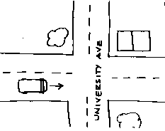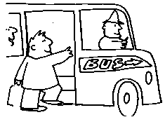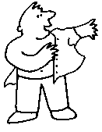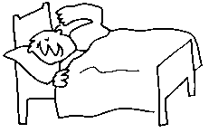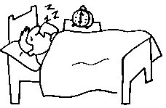









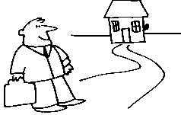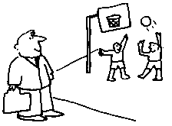

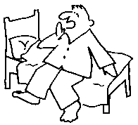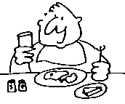

**Rod’s Morning Schedule**

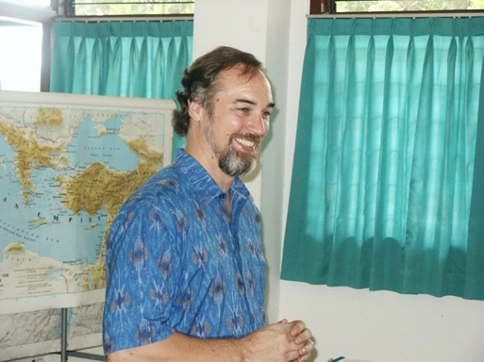

Rod is a seminary professor. He lives in Indonesia. On weekday mornings, Rod gets up around 6:00, and reads his Bible. At 6:30, Rod has breakfast with his wife and daughter. They read the Bible together, and pray for God’s blessing on the day. At 6:45 Rod takes a shower, then takes his daughter to school around 7:00. On Tuesday and Friday mornings, Rod goes to chapel at the seminary where he teaches. Chapel is from 7:45-9:00. Rod stays at the seminary the rest of the morning, working in his office or teaching. On Monday and Wednesday Rod plays tennis from 7:00-8:00, then goes to work at the seminary until noon. On Thursday he works some at home in the morning, then works at the seminary from 9:00-12:00.

**Rod’s Morning Schedule**

|  |  |  |  |  |  |
| --- | --- | --- | --- | --- | --- |
|  | **Monday** | **Tuesday** | **Wednesday** | **Thursday** | **Friday** |
| 6:00-6:30 |  |  |  |  |  |
| 6:30-7:00 |  |  |  |  |  |
| 7:00-7:30 |  |  |  |  |  |
| 7:30-8:00 |  |  |  |  |  |
| 8:00-8:30 |  |  |  |  |  |
| 8:30-9:00 |  |  |  |  |  |
| 9:00-9:30 |  |  |  |  |  |
| 9:30-10:00 |  |  |  |  |  |
| 10:00-10:30 |  |  |  |  |  |
| 10:30-11:00 |  |  |  |  |  |
| 11:00-11:30 |  |  |  |  |  |
| 11:30-12:00 |  |  |  |  |  |

**Karen’s Schedule**

Karen is a mom. She lives in Canada, on a farm. She and her husband also own a store. On weekdays, she gets up around 7:00 and prepares breakfast for her two children. Around 7:30 she goes outside to feed the chickens. Karen teaches her children at home from 8:00-12:00. They have lunch together, then at 1:00 Karen goes to the store to do the accounting. She takes her children. They do school work at the store. They come back home around 2:00. In the afternoons, the children play outside, and Karen does house work or farm work. They have supper together as a family around 5:00. Karen reads to her children then puts them to bed at 8:00. She and her husband go to bed around 10:00. On weekends, Karen spends time with her friends and family.

Karen’s Schedule

|  |  |  |  |  |  |  |  |
| --- | --- | --- | --- | --- | --- | --- | --- |
|  | Monday | Tuesday | Wednesday | Thursday | Friday | Saturday | Sunday |
| 7:00 |  |  |  |  |  |  |  |
| 8:00 |  |  |  |  |  |  |  |
| 9:00 |  |  |  |  |  |  |  |
| 10:00 |  |  |  |  |  |  |  |
| 11:00 |  |  |  |  |  |  |  |
| 12:00 |  |  |  |  |  |  |  |
| 1:00 |  |  |  |  |  |  |  |
| 2:00 |  |  |  |  |  |  |  |
| 3:00 |  |  |  |  |  |  |  |
| 4:00 |  |  |  |  |  |  |  |
| 5:00 |  |  |  |  |  |  |  |
| 6:00 |  |  |  |  |  |  |  |
| 7:00 |  |  |  |  |  |  |  |
| 8:00 |  |  |  |  |  |  |  |
| 9:00 |  |  |  |  |  |  |  |
| 10:00 |  |  |  |  |  |  |  |

**4. Weather and Clothing**

* **I can *read* a paragraph about weather.**
* Use the paragraphs available, with accompanying pictures.
* Have students read and answer the questions.
* Go over answers in groups or all together.
* **I can *read* a weather map, and ask and answer questions with a partner.**
* Use the weather map provided.
* Have students ask and answer questions in pairs, looking at the map. (Sample questions are provided after the map.)
* For extra practice, provide a current weather map of your location from the internet, and do the same activities.
* **I can *describe* what people are wearing, and pictures of clothing.**
* **I can *talk* about appropriate clothing for different weather.**
* Have students describe what other students are wearing.
* Have students look at clothing pictures (or pictures of people), describing the clothing they see.
* Repeat the above activities, only this time make sentences in relation to the weather:

This jacket and pants are good for fall or winter.

That sleeveless top is for summer.

Your flip-flops and umbrella are good for rainy weather.

* Mention a season, and have students suggest appropriate clothing items.
* In pairs, have student A say, “I’m going to….(ex. Bali); student B responds, “You should take…” giving appropriate clothing items.
* **I can *write* about changes in weather or dress.**
* **I can *read* about changes in weather or dress, and *write* questions.**
* Ask students to think of changes in weather or dress, and write 4-5 sentences (not in a paragraph) about these changes, using “used to”. For example:

Women in Indonesia used to wear more traditional dress, but now they wear more Western dress.

I used to wear T-shirts, but now I dress up more.

The rainy season used to start in October, but now it starts in December.

* Have students trade sentences with a partner. Then, have them write a follow-up “why” question for each statement. For example:

Why do Indonesian women wear more Western dress now?

Project: Have students work in groups to create paragraphs with illustrations concerning the weather in Indonesia, weather disasters in Indonesia (floods, drought), or changes in dress or weather in Indonesia.

Weather Events in Indiana, U.S.A.

**Tornados**

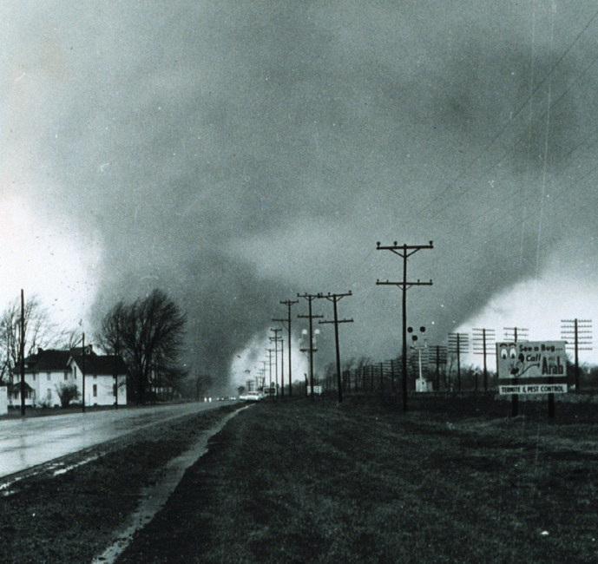In one of the most incredible tornado photographs ever taken, monstrous double tornadoes rip through Midway, Indiana, between Goshen and Elkhart on Palm Sunday, April 11, 1965, at 6:32pm.  These two massive funnels were rotating around each other, and produced F4 damage.  Photo courtesy Paul Huffman, who worked for the *Elkhart Truth* at the time.

1. How many tornados are there?
2. When did the tornados strike?
3. What does “these two massive funnels” mean?
4. Find a word that means “turn in circles”.
5. What do you think “F4 damage” means?

**Ice Storms**

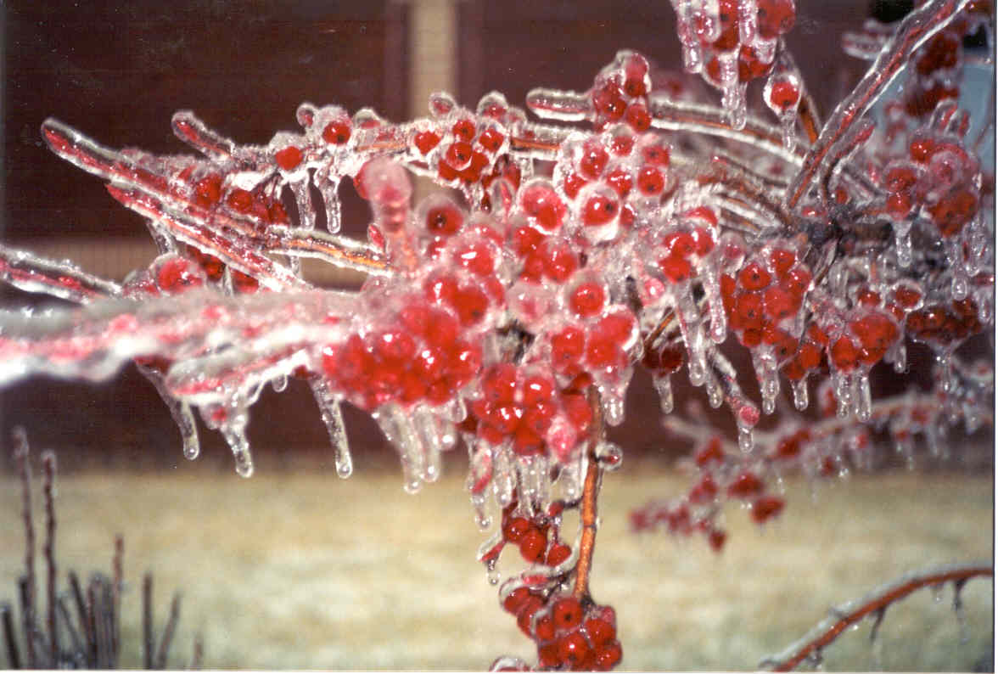

This is the worst ice storm we have ever had! The ice is so heavy on the trees that many branches are falling off. We have been without electricity for four days. Many people are freezing. Fortunately, we have a kerosene heater. We can’t cook because our stove is electric. No one can go out on the roads because they are too icy.

1. Why are branches falling off the trees?
2. What are some problems that people are having?
3. Can you imagine being in an ice storm? How would you feel?
4. What could people in Indiana do to prepare better for ice storms?

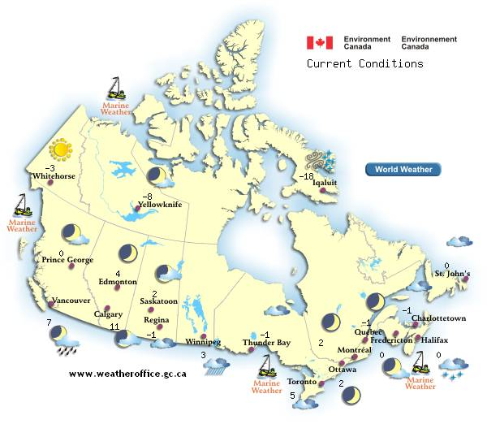**Canadian Weather Map**

Sample Questions

1. What’s the temperature in Regina?
2. Where is it sunny?
3. What’s the weather like in Ottawa?
4. Where is it the warmest?
5. Where is it the coldest?
6. Where is it raining?

Whitehorse

**5 Day Forecast from Environment Canada**

**Friday night**

Cloudy periods

* Low -13°C

**Cloudy periods**

**Saturday**

A mix of sun and cloud

* High -4°C

**A mix of sun and cloud**

**Saturday night**

Cloudy periods

* Low -16°C

**Cloudy periods**

**Sunday**

Sunny

* High -5°C

**Sunny**

**Monday**

Sunny

* High -7°C
* Low -21°C

**Sunny**

**Tuesday**

Sunny

* High -11°C
* Low -21°C

**Sunny**

**What are they wearing?**

