English for Life

Curriculum for
LEVEL 3

Theme:
COMMUNITY

Jan E. Dormer

Teacher’s Notes

This material is part of English for Life – a system and curriculum for teaching English in EFL contexts. The companion document “English for Life Teacher’s Guide” provides the complete information that you will need to teach this curriculum. Here, a brief summary is provided.

English for Life Content

The English for Life system stresses class content that is:
- Communicative: focused on developing reading, writing, speaking and listening skills.
- Contextualized: relevant to students’ real needs in using the English language; authentic materials are encouraged when they are relevant and appropriate for the language level.
- Edifying: helping students and teachers learn and grow as individuals, and in relationship with one another. This material is appropriate for use in Christian ministry. It provides options for using Christian content in contexts where this would be appropriate and useful for meeting students’ needs.

The English for Life curriculum does not use a textbook (except for grammar instruction) and instead guides teachers in developing classroom activities on interesting themes, which will engage learners in real use of the English language. Eight units are provided in each of five levels. Usually a unit can be completed in two weeks, with four hours of instruction per week, and a level can be completed in a semester.

In this curriculum, each level has a theme:

Level | Theme/Focus | Content
Level 1 | Basic Vocabulary and Phrases | greetings, food, home, family, numbers and money, community
Level 2 | Home and Family | introductions, descriptions, jobs, home life,  house, schedules and habits
Level 3 | Community | the neighborhood, stores, services, directions, professions
Level 4 | The World | culture, customs, holidays, geography, countries
Level 5 | Personal Development | spiritual life, traditions, beliefs, worldview, spiritual truth, missions

The English for Life System
This system was developed as a complete learning package, which includes various types of classes and English learning opportunities. The complete system is outlined in the document English For Life: Program Information and Teacher’s Guide.

This curriculum guide provides materials for the heart of the English for Life system: the Core Class. The majority of core class time is spent in the activities highlighted in this curriculum.

We suggest that students also need some grammar study (not to exceed ¼ of their class time). In the curriculum overview on page 5 suggestions for grammar study during each unit are given. Beyond this overview, grammar is not addressed in this curriculum guide. More information on the teaching of grammar within this system can be found in the English for Life Teacher’s Guide.

An overview of Bible verses to be memorized at this level is provided here. This has been an effective part of language learning and personal growth for past students in this system. However, the use of Bible verses should be determined by the teaching context.

A key feature of this system is its Task-based Syllabus. The goals of each unit are framed in terms of tasks. These goals are given to students as they begin each level, being called their “Ability Checklist.” This checklist serves as a roadmap for teachers and students as they go through the level. Teachers organize classroom activities so that students can engage in the tasks, and students check off the tasks as they feel they are able to do them. This type of assessment of skills, focused heavily on self-assessment, is another important element of English for Life, which is also explained more fully in the Teacher’s Guide.

Student Projects
At each level, teachers and students are encouraged to work towards the production of something of value to others, through their classroom activities. This may be a booklet providing information for foreigners, a video, or a web site. When students are involved in creating something that has value beyond the classroom, their motivation for language learning is enhanced. The curriculum guides at each level provide ideas for the development of this student project.

Using this Curriculum Guide
On the following pages you will find these documents for this level:
- Curriculum overview
- List of Bible verses
- Student project ideas
- Ability Checklist

The Ability Checklist and the list of Bible verses (if used) should be given to the students when they begin the curriculum. Other documents to give to students include the Effort Checklist and vocabulary sheet, found in the Teacher’s Guide.

The remainder of this curriculum guide consists of one-page teacher’s guides for each unit, followed by materials that the teacher may find useful in teaching the unit. The teacher’s guides provide suggestions for activities through which students can engage in each task. Following each one-page guide, the materials mentioned in the guide are provided.

While it is possible to teach this curriculum only using the materials provided here, we urge teachers to contextualize their materials as much as possible, finding and creating more appropriate resources for their own students. For example, when students are learning to buy and sell in English, using play money can make the activity more interesting. American currency is provided here. However, if an Australian teacher is teaching this curriculum in Indonesia, and there are students in the class who are planning to visit Australia, it might be much better to help students learn the Australian monetary system.

If you only have a hard copy of this book, you can receive a copy by email by contacting me at jandormer@bigfoot.com. Once this material is on your computer, you can adapt and change it to fit your local context. This material is geared to the Indonesian context. So, one of the first things you will want to do to contextualize is to use the “edit” function to locate all instances of “Indonesia” and replace them with the name of the country in which you work.

Much more contextualization is possible with this material. It is hoped that this curriculum will serve as a catalyst, and that by developing the ideas here teachers can provide excellent classroom activities that do not depend on a textbook, and which meet their students’ needs in many different ways.

Curriculum: Level 3: Community

TOPIC  (each approx.  2 weeks) | THEMATIC CONTENT | GRAMMAR  Basic Grammar in Use (Raymond Murphy)  Units 22-23; 40-74 | BIBLE VERSES
1. People in the community | - jobs and professions  - Character qualities important for various jobs  - Interviewing | - U. 45: Is it? Do they?  - U. 46: who  - U. 47: who/what  - U. 48: what/which/ how | John 3:16a
2. Living in a community | - transportation  - buildings: church, school, store, bank, etc.  - telephone skills  - dialogs in public places  - politeness in public | - U. 49: how long  - U. 50: do you know where…?  - U. 51: reported speech  - U. 52-53: gerunds and infinitives | John 3:16b  I Cor. 13:4
3. Maps, Location, directions | - understanding signs  - expressions for direction  - reading maps  - asking for help  - asking for clarification | - U. 40: it  - U. 56: go  - U. 57: get  - U. 58: do and make  - U. 59: have | I Cor. 13:5  I Cor. 13:6
4. Health | - describing physical symptoms  - health care places  - discussing medications  - exercise  - prayer requests | - U. 41: I am, I don’t  - U. 42: you have…  - U. 43: too, so, either, neither  - U. 44: negatives | I Cor. 13:7,8a  I Cor. 13:13
5. Safety | - expressions for safety and security  - emergencies | - U. 22-23: passive  - U. 60: pronouns  - U. 61-62: possessive pronouns | Ps. 121:1  Ps. 121:2
6. Restaurants | - reading menus  - ordering in a restaurant  - expressing preferences  - reading and writing restaurant reviews | - U. 66: a/an  - U. 67: singular & plural  - U. 68-69: countable & uncountable  - U. 70: a/an & the | Ps. 121:3  Ps. 121:4
7. Shopping | - store categories  - common products  - words associated with sales: sell, discount, return, refund, price, quality  - understanding money and payment | - U. 54: I want you to  - U. 55: I went to the store to…  - U. 63: pronoun forms  - U. 64: reflexive pronouns  - U. 65: possessives | Ps. 121:5  Ps. 121:6
8. Responsibilities | - social services (provision for the poor or needy)  - words related to government and civic responsibility: voting, election  - reading and evaluating advertisements  - local volunteer projects | - U. 71: the  - U. 72: go to work, go to the movies  - U. 73: like/hate  - U. 74: place names | Ps. 121:7  Ps. 121:8

Bible Verses: Level 3

John 3:16 For God so loved the world that he gave his one and only Son,

That whoever believes in him shall not perish, but have eternal life.

THE LOVE PASSAGE

I Corinthians 13:4 Love is patient, love is kind. It does not envy, it does not boast, it
is not proud.

I Corinthians 13:5 It is not rude, it is not self-seeking, it is not easily angered, it keeps
no record of wrongs.

I Corinthians 13:6 Love does not delight in evil but rejoices with the truth.

I Corinthians 13:7,8a It always protects, always trust, always hopes, always perseveres.
Love never fails.

I Corinthians 13:13 And now these three remain: faith, hope and love. But the
greatest of these is love.

THE FRUIT OF THE SPIRIT

Galatians 5:22,23a The fruit of the spirit is love, joy, peace, patience, kindness,
goodness faithfulness, gentleness and self-control.

Psalm 121

Psalm 121:1 I lift up my eyes to the hills – where does my help come from?

Psalm 121:2 My help comes from the Lord, the Maker of heaven and earth.

Psalm 121:3 He will not let your foot slip – he who watches over you will not
slumber;

Psalm 121:4 Indeed, he who watches over Israel will neither slumber nor sleep

Psalm 121:5 The Lord watches over you – the Lord is your shade at your right
hand;

Psalm 121:6 The sun will not harm you by day, nor the moon by night.

Psalm 121:7 The Lord will keep you from all harm – he will watch over your life;

Psalm 121:8 The Lord will watch over your coming and going both now and
forevermore.

Student Project Ideas

Level Three focuses on the theme of “Community.” Students will learn to talk about stores, places of worship, maps, services, and other ideas related to public life in a community.

The project suggested at this level is a “Handbook for Foreigners in this City.” Students will be engaging in activities such as creating directions, making observations about city signs, considering what constitutes polite behavior in public, and more. These activities easily lend themselves to the creation of a booklet which could be very useful for new arrivals to the city, country, or culture.

The following documents and articles are natural products of the class tasks, and can be collected to make a booklet: (Indonesia is used as an example)

Indonesian jobs (and how some might differ from jobs in other countries)

How to be polite in public in Indonesia

Understanding Indonesian signs

Some important places in this city, and where they are located

Indonesian medication and treatments for common illnesses

Important safety precautions in Indonesia

Good restaurants in this city, and where they are located

Shopping in Indonesia

The information generated by the students on these topics can, at the end of the semester, be put into booklet form (preferably by the students themselves) and sold to foreigners in the city. Students should add their names and pictures to their contributions, so they can be acknowledged for their valuable work!

ABILITY CHECKLIST, LEVEL 3
Community

Name: ___________________________________ Dates: ___________________________

NOTE: Check when you can do these things:
1) Without much hesitation
2) With a native speaker (preferably)
3) Without too many mistakes (about 70% accuracy)

1. People in the community
- I can describe people who do different jobs (both character and job descriptions).
- I can understand and answer questions about different occupations.
- I can read about different professions, and answer questions.
- I can ask questions about someone’s job, and explain my job by answering questions.
- I can write a description of my job, or my ideal job.
- Vocabulary: I know words for many different kinds of occupations.

2. Living in a community
- I can describe my community or neighborhood in conversation.
- I can ask questions about someone’s community or neighborhood.
- I can take a phone message.
- I can communicate in public places such as the post office or a bank.
- I can read about common courtesies needed in a community.
- Vocabulary: I know words for different kinds of stores and transportation.

3. Maps, Location, Directions
- I can understand city signs, and describe them in English.
- I can give directions to important places in my city.
- I can understand directions and write them down.
- I can ask for help in finding a place when I’m lost; I can give help to a stranger.
- I can ask for clarification when I didn’t understand the first time.
- Vocabulary: I know phrases for giving directions.

4. Health
- I can describe physical symptoms and ask for advice.
- I can understand descriptions of physical symptoms, and give advice.
- I can discuss medicines, and how to take them.
- I can read about different kinds of exercise, and write about my habits.
- I can read an article about health, take notes, and discuss it.
- I can share a prayer request and pray about a physical problem.
- Vocabulary: I know words for health care places, medicines, and conditions.

5. Safety
- I can report an emergency to 911.
- I can ask questions about an emergency, such as address, condition, etc.
- I can read about safety for foreigners in Indonesia, and tell a foreigner how to be safe here.
- I can write about a personal experience, involving an emergency or safety.
- I can read about someone’s experience, and ask questions.
- Vocabulary: I know words for emergencies and crimes.

6. Restaurants
- I can read a restaurant menu, and ask questions about it.
- In a restaurant, I can: order, ask and answer questions, and ask for the bill.
- I can express and understand food preferences.
- I can recommend a local restaurant that foreigners might enjoy, in speaking and in writing.
- I can pray before a meal.
- Vocabulary: I know words and phrases for ordering in a restaurant.

7. Shopping
- I can talk with someone about where and how to buy food.
- I can read product labels, and ask questions about products.
- I can talk with sales people in different kinds of stores.
- I can understand a price given in U.S. currency, and give the right amount.
- I can participate in a typical conversation about paying by credit.
- I can write a paragraph related to shopping.
- I can read someone’s paragraph, and write follow-up questions.
- Vocabulary: I know types of stores and products, and vocabulary about payment.

8. Responsibilities in a Community
- I can discuss civic responsibilities and tell about my involvement.
- I can understand and fill out an internet volunteer registration form.
- I can read a story about volunteering, and take notes.
- I can read about a volunteer opportunity.
- I can write a letter applying for a volunteer position, and answer questions in an interview.
- I can compare volunteering in the U.S. and Indonesia in a discussion.
- I can give a report about a local volunteer project, and answer questions.
- Vocabulary: I know words related to civic duties and volunteering.

Christian Content
- I can say John 3:16 Listener: _____________
- I can say I Corinthians 13:4-8a, 13 Listener: _____________
- I can say Galatians 5:22,23a Listener: _____________
- I can say Psalm 121 Listener: _____________
- I can write about changes and growth in my spiritual life.

1. People in the Community

- I can describe the people who do different jobs (both character and job descriptions).
- Show pictures of various occupations. In pairs or as a group, have students talk about each occupation, describing qualities required for it. For example:
This is a chef.
A chef should like food.
He should be very clean.
He should understand a lot about food interactions, flavors and spices.
He should know a lot about nutrition.
A chef must work late at night.
Chefs are often particular and perfectionist.

- I can understand and answer questions about different occupations.
- Play “Who am I”. Put the name of an occupation on each student’s back. The student must ask other students yes/no questions until he can guess the occupation. For example:
Do I wear a uniform?
Do I work late at night?
Am I often a woman?
Do I help people?

- I can read about different professions and answer questions.
- Have students read about people who do different jobs, filling out “What is this Job Like?” for each as a way of taking notes on the readings.

- I can ask questions about someone’s job, and explain my job by answering questions.
- Using the form, “What do you do?” have students work in pairs to ask and answer questions about their jobs.

- I can write a description of my job, or my ideal job.
- Suggest that students write 4-5 sentences about their jobs, including:
What the job is
What tasks it involves
What character traits are necessary
Pros and cons
- Have students prepare a description of their job with their picture, as in the examples given earlier. Put descriptions on the board, or make into a booklet.

Occupations

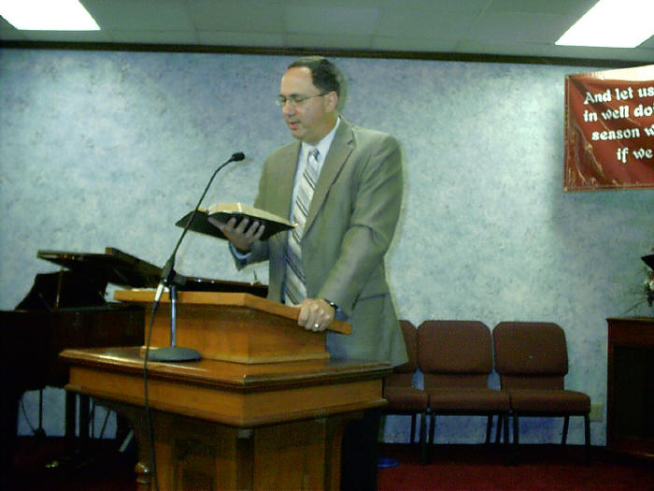
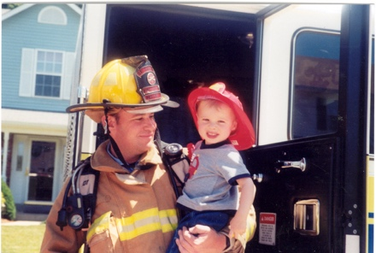

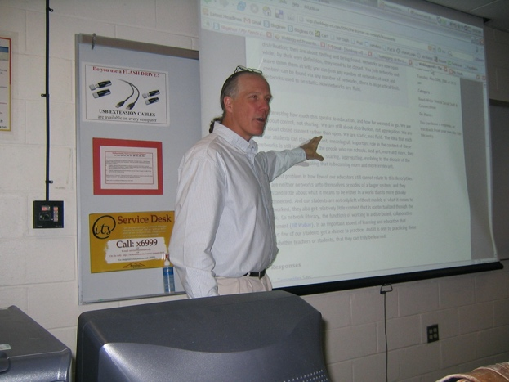

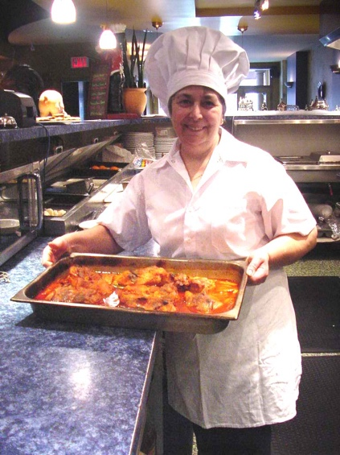

Read about what these people do!

A Councilman
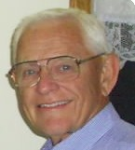
My name is Max, and I am a councilman. I represent three townships in my county. It is my responsibility to help the people in these townships get what they need and deserve from the county government. Also, I along with six others must protect the population from unfair taxation. Why did I get involved in county government issues? My mother once told all of her children the following: "Sometime in your life you need to 'give back' to your community. Watch for the right time to do this." I believe this is 'my' time to give back to my community. And I thank God for the privilege.

A Teacher

My name is Jason, and I'm a social studies and Bible teacher in a Christian school in Brazil. I work with high school students. I prepare lessons and help students understand important stories and concepts which have shaped the modern world. Also, I get to be involved with the students as a soccer coach, developing their endurance and ball skills as well as their minds. It is a rewarding type of work, because I’m investing in the most valuable resource in the world: people.

A Pastor’s Wife

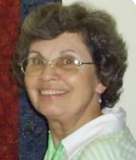
My name is Dixie, and I am a pastor’s wife. The wife of a pastor is a blest person. The pastor is a servant of the Lord, and she is in a position to minister to and serve the servant of the Lord.
When I was a little girl I often thought how special it would be to be a pastor's wife. When I married a farmer it appeared that I would never be a pastor's wife. How wrong I was! We've been married 50 years now. While we were missionaries in Brazil, I was a pastor's wife in three different churches. Now in our retirement days we are still pastoring a church and my husband is 74 years old!
My responsibility is to live 'with eternity's values in view'. My priorities must be in line with biblical values. I must be trustworthy and guard confidences. I must control my tongue so my words are always a blessing and never hurtful to others. I must always be 'an example of the believers'. I must love and care for this servant with whom I live. My pastor husband is my first responsibility next to God. Also, my home must reflect His peace. I have always prayed that when people walk into my home they would sense the peace of God. My home belongs to Him and I want His Presence to be known.
I thank God for the privilege of being a pastor's wife. I Cor. 15: 58 says, “Therefore, my dear brothers (sisters), stand firm. Let nothing move you. Always give yourselves fully to the work of the Lord, because you know that your labor in the Lord is not in vain.” My prayer is to be faithful and to always "give myself fully to the work of the Lord."
A Banker
My name is Joe and what I do to earn money for my family is work for Citibank. After getting my MBA in International Business I joined Citibank Latin America and had several different jobs where I got to live in Florida and travel to the major countries in Latin America. Then my family and I moved to Panama for a couple of years, where I got the chance to help build up a team that was able to turn around a money-losing business and make it profitable.
After Panama, we moved to Texas, where we currently live. Citibank bought another bank here in 2005, and I am part of the team that is helping this new bank begin to act like Citibank. Right now, I help 50 bank branches hit their sales goals. I really enjoy challenging people to reach new objectives, and coaching them to great success. What gives me the most pleasure in my career is seeing the people I work with grow professionally, and building or changing an organization.
Banking is full of people from different backgrounds with different beliefs. Most of my co-workers are highly successful but do not yet have a clear idea of what is most important in life and tend to not stop and think about it. For now, I believe God has me here to walk into the spaces He creates in people’s lives and show them His love and truth by my words and my actions. I pray that He can use me in this way.

What is this job like?

Person’s name: ____________________

Job: _____________________________

Activities on the job: _________________________________________
___________________________________________________________
___________________________________________________________

Qualities needed on the job: ___________________________________
___________________________________________________________
___________________________________________________________

Pros and cons of the job: ______________________________________
___________________________________________________________
___________________________________________________________

Person’s name: ____________________

Job: _____________________________

Activities on the job: _________________________________________
___________________________________________________________
___________________________________________________________

Qualities needed on the job: ___________________________________
___________________________________________________________
___________________________________________________________

Pros and cons of the job: ______________________________________
___________________________________________________________
___________________________________________________________

What Do You Do?

How do you ask questions about someone’s job? Write the questions first. Then interview a classmate to find out about his or her job. Write the answers, so you can tell your classmates about this person’s job.

Name of the person you are interviewing: _________________________

Topic | Question | Answer
Job

Hours

Responsibilities

Important qualities
Positives

Negatives

Feelings about

job

2. Living in a Community

- I can describe my community or neighborhood in conversation.
- I can ask questions about someone’s community or neighborhood.
- Have students complete the Neighborhood Checklist about where they live.
- After completing the checklist, have students interview each other about their neighborhoods. Have them ask questions such as:
Is your neighborhood noisy?
Are your neighbors friendly?
Do you live near a store?
Do you live near a bus stop?
- Have students take turns telling the class about their partner’s neighborhood.

- I can take a phone message.
- Using the “While you were out” form (or real message forms), have students practice taking messages, as the teacher “calls” them.
- Provide students with “caller” cards (or situations related to their context). Have students role play caller and person taking message in pairs.

- I can communicate in public places, such as the post office or the bank.
- Have students role play customer and worker at the post office and at a bank, using the handout on “Communicating in Public Places.”
- In pairs, have students write a dialogue that could take place in an office, a bank, or another public place in Indonesia (only write it in English!) Have pairs present their dialogues to the class.

- I can read about common courtesies needed in a community.
- Dramatize some scenarios of people acting rude, such as cutting in line, honking and yelling at other drivers, or a sales clerk or a customer being rude. Discuss the scenarios, and ask students to give other examples of rudeness in public places.
- Have students read “Rudeness in Public”; have students tell each other, in pairs, the three things that the author doesn’t like.
- In small groups, have students identify common instances of rudeness in Indonesia. Urge them to come up with ways to help people become more polite. Have students make posters that would foster politeness, and put them up around the school.

Neighborhood Checklist

What is your neighborhood like? Are you happy with your neighborhood, or would you like to live in a different kind of neighborhood?

My neighborhood is…

_____ quiet _____ noisy
_____ safe _____ dangerous
_____ clean _____ dirty
_____ like a family _____ like strangers
_____ near school _____ far from school

My neighborhood has…

_____ a lot of trees _____ few trees
_____ public transportation _____ no public transportation
_____ a lot of children _____ few children
_____ a lot of traffic _____ little traffic
_____ many shops _____ few shops

I like my neighborhood because…

I like living….

I wish I lived…

Someday I plan to live…

While you were out…

Message for: _________________ Date: ___________ Time: _______

Message: ____________________________________________________________________________________________________________________________________________________________________________________________________________________________________________________

Message taken by: ____________________

While you were out…

Message for: _________________ Date: ___________ Time: _______

Message: ____________________________________________________________________________________________________________________________________________________________________________________________________________________________________________________

Message taken by: ____________________

While you were out…

Message for: _________________ Date: ___________ Time: _______

Message: ____________________________________________________________________________________________________________________________________________________________________________________________________________________________________________________

Message taken by: ____________________

Caller Cards

1. You have an appointment to get your hair cut at 3:00. But you are running late, and can’t make it to the salon until 3:15. Call the salon. | 2. You would like to invite your friend Rose to a Bible study on Tuesday night at 7:00. Her husband answers the phone. Give him the information.
3. Your child is sick and can’t go to school today. Call the school and tell them why your child isn’t there. | 4. You have had an accident and urgently need to contact a friend who can come and help you. You are calling from your cell phone, and need to give your location.
5. You agreed to help on the committee to decorate the church for Christmas. But now you feel you are too busy, and would like to get out of it. Call and politely excuse yourself. | 6. You have invited a friend to a drama being presented at your church. You call to let him know what time you will pick him up. He is not in, so you leave the message with a friend.

Communicating in Public Places

Post Office:
- May I help you?
- I would like to mail ___________.
- Okay, it’s ______________.
- Thank you.
- You’re welcome.

- Hello, how may I help you?
- I need to pick up ___________ for_________(name).
- Okay, here’s your ____________.
- Thank you.
A. Have a good weekend.

Bank:
- Can I help you?
- I would like to cash this check.
- How do you want the money?
- In _________________.
- Here’s the money.
- Thanks.
- You’re welcome

- Hello, may I help you?
- I need to pay _____________. Here is the ___________.
- Here is your receipt.
- Thank you.
A. Have a nice day.

Rudeness in Public

Does it bother you when people are rude? It bothers me! Though I hate any kind of rudeness in public, three things really bother me.
First, I hate it when people cut in line. Has that ever happened to you? You’re in a long line at the bank or the grocery store, and are trying to patiently wait your turn, when someone just gets in line in front of you. Or worse yet, people begin crowding in, apparently ignoring the line!
Second, I really don’t like it when people interrupt meetings or conversations by taking cell phone calls. Sometimes, you can’t have a conversation with someone, because the conversation is always being interrupted by a phone call! Am I less important than the person calling on the phone? That’s how I feel!
Finally, it bothers me when clerks in stores are either too helpful or not helpful enough. Sometimes they hover over me, even though I have already said that I just wanted to look. At other times, I want to ask a question, but either I can’t find a clerk, or the clerk doesn’t want to get up from her seat and come help me. I think that store clerks get paid to give customers the proper amount of help, and that’s exactly what they should do!
If people weren’t rude in these ways, I would enjoy going out in public a lot more! But…I need to remember that I am part of the “public” too. I must remember to be polite to everyone I meet – even to people who are rude. After all, this is what Jesus meant when He urged us to “love our neighbor,” even if that neighbor is an obnoxious person who cuts in line!

3. Maps, Location, Directions

- I can understand city signs, and describe them in English.
- Show pictures of American signs. Have students say what they think it means. Put on board the beginning of the sentence: “This sign means that you have to ………...” Help students understand that they could use “have to” or “must”.
- In groups, have students make a list of signs found in Indonesia, and explain their meanings to the teacher. Then, have them compare and contrast signs and their meanings in America and in Indonesia, and share the differences with the class.
- Play charades. Have one student try to show a sign by gesturing, and the others try to guess what sign it is. Suggested signs:
Stop sign Pedestrian crossing
No parking School zone
Bus stop Caution

- I can give directions to important places in my city.
- I can understand directions and write them down.
- Provide a map of the school campus. In pairs, have students practice giving instructions to each other on how to find their English class when they come on campus. Practice: turn right/left; go straight/up/down; first door on the right, etc.
- Have students work in groups to prepare written instructions to get from the school to some well-known places in town. Collect these written instructions and create a handout that would be helpful for a foreigner in Malang.
- Have students work in pairs, taking turns giving and writing down how to get from the school to their homes.

- I can ask for help in finding a place when I’m lost; I can give help to a stranger.
- Brainstorm phrases that could be used when you need to ask a stranger for help in finding someplace (Excuse me, could you help me, I’m looking for…, I’m lost)
- In pairs, have students role play being lost and needing help. Give students these situations:
  - Someone in a car comes to a gas station and asks for the nearest hotel.
  - Someone stops at the English school and asks where the nearest grocery store is.
  - Someone stops you on the street and asks how to get to the hospital.

- I can ask for clarification when I didn’t understand the first time.
- Repeat some of the previous role-plays. However, this time have the student asking for directions request clarification several times. In fact, the person giving directions can mumble or not be clear on purpose. Encourage the use of phrases such as, “I’m sorry, could you repeat that?” “I’m sorry, but I don’t understand.” “Did you say turn RIGHT?”
- Encourage students to continue using clarification techniques in class.

Road Signs

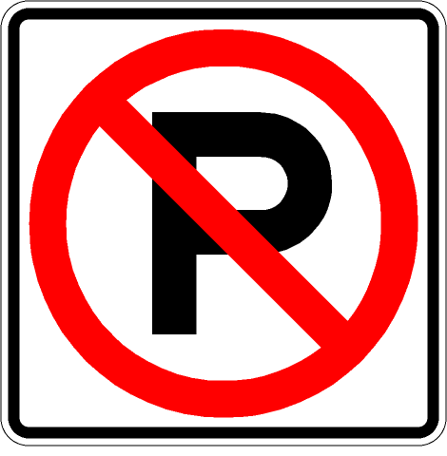
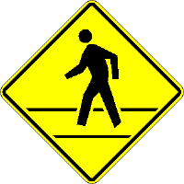
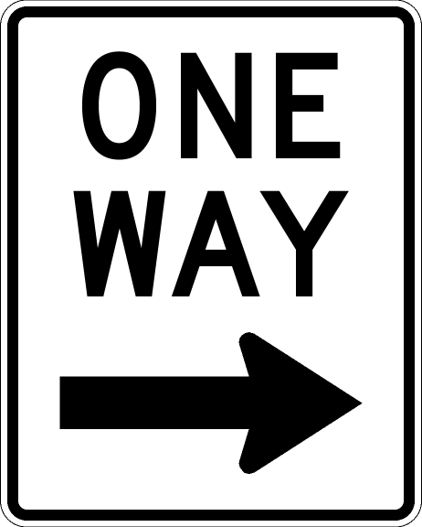

4. Health

- I can describe physical symptoms and ask for advice.
- I can understand descriptions of physical symptoms, and give advice.
- Teach students how to say something hurts: “I have a ____ache” can be used for head, stomach, back, and tooth. All body parts can use the form, “My ___ hurts.”
- Have students practice telling each other a few symptoms, and asking “What should I do?”
- Brainstorm other symptoms: fever, vomiting, diarrhea, lack of appetite, etc.
- Brainstorm advice that might be given:
  - You should go to bed.
  - You should take Tylenol.
  - You should use heat/cold.
- Role play patient (giving symptoms) and doctor (giving advice) in pairs.

- I can discuss medicines, and how to take them.
- Look at real medicine (with English labels) from a typical family medicine chest. Have students pass items around, and write down common information found on medicine, such as: how often and how to take, how much to take (for different ages), what the medicine will do and possible side effects, expiry date.
- In small groups have students tell about medicines that they or someone in their family has taken. Have them make sentences such as:
My thyroid medication must be taken in the morning.
I give my son takes 10 drops of liquid Tylenol before bed when he has a fever.
- Have students bring in a kind of medicine that they would suggest a foreigner buy in Indonesia. Have them tell the teacher what the medicine does, what it says on the packages, and where they can buy it.

- I can read about different kinds of exercise, and write about my habits.
- In pairs, have students complete the exercise survey. Have pairs share with the class, and discuss any differences of opinion.
- In class, discuss differences between Indonesian and American ideas of exercise.
- After the discussion, have students write a paragraph about their exercise habits.

- I can read an article about health, take notes, and discuss it.
- Provide the articles on “Health Tips”.
- Have students read an article and write 3-5 things that stood out to them.
- Have students compare their lists, talking about differences and similarities.
- If time permits, have students read several other articles taken from internet or from magazines.

- I can share a prayer request and pray about a physical problem.
- This can be done throughout the semester.
Exercise Survey

What do you think these exercises are good for?

Say: “I think that _______ is good for _______.”

What is it good for? > | A healthy heart | Weight loss | Strengthening muscles | Relieving stress
Swimming

Running

Walking

Lifting weights
Jumping rope

Yoga

Bike riding

Which types of exercise are common in Indonesia?

Which types of exercise do YOU do?

Which types of exercise do you THINK you should do?

Do you think that most Indonesians are physically fit? Why or why not?

10 Essential Health Tips
(The Basics to Practice Every Day)
Taken from: http://www.health-fitness-tips.com/features/10-essential-health-tips.htm
1. Move More
Make it a daily challenge to find ways to move your body. Climb stairs if given a choice between that and escalators or elevators. Walk your dog; chase your kids; toss balls with friends, mow the lawn. Anything that moves your limbs is not only a fitness tool, it's a stress buster. Think 'move' in small increments of time. It doesn't have to be an hour in the gym or a 45-minute aerobic dance class or tai chi or kickboxing. But that's great when you're up to it. Meanwhile, move more. Thought for the day: Cha, Cha, Cha…. Then do it!
2. Cut Fat
Avoid the obvious such as fried foods, burgers and other fatty meats (i.e. pork, bacon, ham, salami, ribs and sausage). Dairy products such as cheese, cottage cheese, milk and cream should be eaten in low fat versions. Nuts and sandwich meats, mayonnaise, margarine, butter and sauces should be eaten in limited amounts. Most are available in lower fat versions such as substitute butter, fat free cheeses and mayonnaise. Thought for the day: Lean, mean, fat-burning machine…. Then be one!
3. Quit Smoking
The jury is definitely in on this verdict. Ever since 1960 when the Surgeon General announced that smoking was harmful to your health, Americans have been reducing their use of tobacco products that kill. Just recently, we've seen a surge in smoking in adolescents and teens. Could it be the Hollywood influence? It seems the stars in every movie of late smoke cigarettes. Beware. Warn your children of the false romance or 'tough guy' stance of Hollywood smokers. Thought for the day: Give up just one cigarette…. the next one.
4. Reduce Stress
Easier said than done, stress busters come in many forms. Some techniques recommended by experts are to think positive thoughts. Spend 30 minutes a day doing something you like. (i.e.,Soak in a hot tub; walk on the beach or in a park; read a good book; visit a friend; play with your dog; listen to soothing music; watch a funny movie. Get a massage, a facial or a haircut. Meditate. Count to ten before losing your temper or getting aggravated. Avoid difficult people when possible. Thought for the day: When seeing red, think pink clouds….then float on them.
5. Protect Yourself from Pollution
If you can't live in a smog-free environment, at least avoid smoke-filled rooms, high traffic areas, breathing in highway fumes and exercising near busy thoroughfares. Exercise outside when the smog rating is low. Exercise indoors in air conditioning when air quality is good. Plant lots of shrubbery in your yard. It's a good pollution and dirt from the street deterrent. Thought for the day: 'Smoke gets in your eyes'…and your mouth, and your nose and your lungs as do pollutants….hum the tune daily.
6. Wear Your Seat Belt
Statistics show that seat belts add to longevity and help alleviate potential injuries in car crashes. Thought for the day: Buckle down and buckle up.
7. Floss Your Teeth
Recent studies make a direct connection between longevity and teeth flossing. Nobody knows exactly why. Perhaps it's because people who floss tend to be more health conscious than people who don't? Thought for the day: Floss and be your body's boss.

8. Avoid Excessive Drinking
While recent studies show a glass of wine or one drink a day (two for men) can help protect against heart disease, more than that can cause other health problems such as liver and kidney disease and cancer. Thought for the day: A jug of wine should last a long time.
9. Keep a Positive Mental Outlook
There's a definitive connection between living well and healthfully and having a cheerful outlook on life. Thought for the day: You can't be unhappy when you're smiling or singing.
10. Choose Your Parents Well
The link between genetics and health is a powerful one. But just because one or both of your parents died young in ill health doesn't mean you cannot counteract the genetic pool handed you. Thought for the day: Follow these basic tips for healthy living and you can better control your own destiny.

