**5. Safety**

* **I can *report* an emergency to 911.**
* **I can *ask* questions about an emergency, such as address, condition.**
* Brainstorm words for emergencies and crimes (fire, robbery, explosion, gunshot, accident, illness, unconscious, not breathing)
* Discuss what’s important in an emergency: what happened, how the person is hurt, providing address and phone number.
* Have students role play reporting emergencies, with one student calling, and one student acting as the 911 operator. Give them scenarios such as the following:

A building is on fire, and someone is trapped upstairs.

A child took his mom’s medication.

Your husband fell off the roof, and can’t move.

* **I can *read* about safety for foreigners in Indonesia, and *tell* a foreigner how to be safe here.**
* Give the reading “How Visitors to Indonesia Can Stay Healthy.” Explain that this is a real document provided by an organization that brings foreigners to Indonesia.
* Have students work in pairs to create a list called “The 10 Commandments of Staying Safe and Healthy in Indonesia.” They can use ideas from the reading, plus their own ideas. Have them phrases sentences as, “Visitors to Indonesia should…”
* Role-play foreigner and Indonesian. The foreigner should begin by saying, “I’m new to Indonesia. Can you tell me how to stay healthy here?” The person playing the role of Indonesian should speak extemporaneously or from notes.
* Have students ask you questions about safety that they would want to know if they were traveling to America (or another foreign country).
* **I can *write* about a personal experience, involving an emergency or safety.**
* **I can *read* about someone’s experience, and *ask* questions.**
* Have students write about a personal experience involving an emergency or health issue. Stress that they answer all the wh-questions: who, what, when, where, why
* After students have edited their writing, have them read about one another’s experiences.
* After reading, have students ask the author at least three questions about the story.

**How Visitors to Indonesia can Stay Healthy**

***Shots:***

We do not require any specific shots other than having your tetanus up-to-date. You may want to get hepatitis vaccinations. Malaria is **not** a danger in the developed, urban areas of Indonesia. We will let you know if you will be traveling anywhere where other vaccinations or preventions are necessary.

***General rules regarding food:***

* Do not eat uncooked foods without being certain of the preparation. You can easily pick up a bug which will cause you a great deal of intestinal discomfort and difficulty.
* Do not drink unboiled or unbottled water: If you cannot get bottled or boiled water, stick to cokes or other soft drinks. Water should be boiled at least 20 minutes to be safe.
* Wash your hands frequently. Germs are abundant, and can easily get into your body from your hands to your mouth or eyes.
* Report any known food allergies to upon your arrival in Indonesia. If you have a serious allergy to a common food, please let us know ***prior to your arrival*** so that we can plan meals accordingly.

***Illness:***

* Diarrhea and vomiting should be reported immediately. Drink plenty of fluids and rest. Medication may be needed.
* Pink eye is common here. Report any signs of pink eye, so you can begin medication promptly. Try not to touch your eyes.
* Fever can indicate a variety of illnesses. Report immediately.
* Cuts or sores can take longer to heal here, and the risk of infection is greater. While there’s no need to worry about minor cuts, it is good to treat any sore or cut by cleaning it properly, and applying antibacterial cream.

***Avoiding Illness and Injury:*** *The best cure is prevention!*

* Use sunscreen and mosquito repellent when necessary. (Sunscreen is expensive here. It’s best to bring your own.)
* Get enough rest, and eat nutritiously.
* Look down while you are walking, to avoid twisted ankles or falls due to the many potholes, and near-total absence of flat walking surfaces.
* Wear appropriate shoes and clothing. Plan to wear sunscreen, long sleeves, and a hat if you will be outside for a long time. You will burn quickly here.
* Bring any medications that you know you will need.
* Be extremely careful when walking through or beside traffic. Always assume that the vehicles have the right of way!

A final note about safety: **Make sure someone always knows where you are.** Do not wander off on your own without telling someone where you are going, what route you are taking, and when you will return. If possible, carry a cell phone.

**6. Restaurants**

* **I can *read* a restaurant menu, and *ask* questions about it.**
* Use the Dairy Queen menu provided, or if possible, use real menus.
* Have students imagine that they are at a restaurant ordering from this menu. Have students read over the menu and look at the pictures, asking you anything they don’t understand. For example:

What kind of meat is this?

What does this salad have in it?

Note: you may want to highlight items on the menu that you want particular

students to ask you questions about.

* **In a restaurant, I can *order*, *ask* and *answer* questions, and *ask* for the bill.**
* Brainstorm together phrases that might be used in a restaurant. Use “Restaurant Language” sheet to write the phrases.
* If possible, set up the room to look like a restaurant.
* Have students take turns role playing guests and waiters, using the Dairy Queen menu or other various authentic menus.
* **I can *express* and *understand* food preferences.**
* Have students look at food pictures, preferably pictures of dishes in restaurants. (You may want to use the menu pictures, or the bingo game that has prepared plates of food.) Ask them to express their preferences by making statements:
  + I would rather have chicken than fish.
  + I don’t like onion rings, but I do like fries.
  + I prefer rice over pasta.
* Have each student express at least five food preferences. After each expression, others should give short agreements or disagreements (So do I; I don’t)
* **I can recommend a local restaurant that foreigners might enjoy, in *speaking* and in *writing.***
* Each student should write a paragraph recommending a local restaurant.
* After the writing sequence is complete, students should speak informally with the teacher, to recommend their restaurant. They should be able to provide:

Name and location of restaurant

What type of food it serves

Why well they liked the food

Comments on the service

Comments on the price

* All student paragraphs could be collected, along with photographs of the restaurants, and compiled in a booklet or displayed on the bulletin board.
* **I can *pray* before a meal.**
* Practice this any time you eat real food together as a class.

**Restaurant Language**

*What might be said to communicate the following:*

The waitress greets customers…

* Hi! How are you doing today?

The waitress offers to get customers something to drink…

* Can I get you something to drink to start off with?

The customers order drinks…

* I’ll take…
* I’ll have…
* I’d like…

The waitress asks if the customers are ready to order…

* May I take your order?
* Are you ready to order?

The customers order their food…

* I’ll have…
* I would like…

(Also, ask questions about menu items)

The waitress delivers the food, then checks back…

* Is everything okay?
* Can I get you anything else to drink?
* Would you like some dessert?

The customers ask for the bill…

* Could I please have the bill?
* We’re all finished. Could you please bring us the check?

|  |  |  |
| --- | --- | --- |
| spacerDairy Queen Menu | | |
| DqShakeGroup | spacer | **DQ® Shakes & Malts** Creamy DQ soft serve blended together with milk available in with a variety of flavors.  Medium $2.75  Large $3.50 |
| spacer | | |
| DqSndGrp | spacer | **DQ® Sundaes** For over 60 years DQ® has been know for it's great sundaes. Top one off with hot fudge, caramel or any of our delicious toppings.  Small $1.79  Medium $2.45  Large $3.35 |
| spacer | | |
| DqConesDippedSm | spacer | **DQ® Cones & Dipped Cones** A DQ® classic! Eat it plain or dipped in one of our crunchy cone coatings.  Small $1.50  Large $2.75 |
| spacer | | |
| DqSndwch | spacer | **DQ® Sandwich** Bite into a DQ® Sandwich and taste the sensation of cool Dairy Queen® reduced fat ice cream nestled between two chocolate wafers.  $1.19 |
| spacer | | |
| **Burgers** | | |
| spacer | spacer | spacer |
| BrzrBcnChdrGb | spacer | **Bacon Cheddar GrillBurger™** Thick juicy 1/4 lb. burger, crisp bacon, natural cheddar cheese, pickles, on a butter-toasted bun.  $4.69 |
| spacer | | |
| BrzrMshrmSwssGb | spacer | **Mushroom Swiss GrillBurger™** Thick juicy 1/4 lb. burger, mushrooms, natural swiss cheese, mild garlic mayo on a butter-toasted bun.  $4.25 |
| BrzrUltmtBrgr | spacer | **DQ® Ultimate® Hamburger** The delicious DQ® Ultimate® is a (1/3 lb. total total pre-cooked weight) Homestyle burger loaded with savory bacon, cheese, pickles, lettuce, tomato and our Ultimate sauce.  $4.89 |
| spacer | | |
| BrzrDblChsbrgr | spacer | **Cheeseburger** DQ® Homestyle burger topped with cheese, pickles, ketchup and mustard.  $2.15 |
| spacer | | |
| BrzrDblChsbrgr | spacer | **Hamburger** DQ® Homestyle burger topped with pickles, ketchup and mustard.  $1.99 |
| **Sandwiches** | | |
| spacer | spacer | spacer |
| BrzrFshFlltSndwch | spacer | **Fish Fillet Sanwich** A crispy breaded fish fillet on a toasted sesame bun with tarter sauce and green leafy lettuce.  $2.99 |
| spacer | | |
| BrzrGrlldChckn | spacer | **Grilled Chicken Sandwich** A juicy grilled chicken breast, fresh lettuce, tomato and mayonnaise on a wheat bun.  $3.25 |
| spacer | | |
| **Baskets** | | |
| spacer | spacer | spacer |
| BrzrOrgnlChcknStrpBskt1 | spacer | **Chicken Strip Basket** Four golden strips of tender chicken breast served with crispy fries, Texas Toast and delicious country gravy.  $3.65 |
| spacer | | |
| BrzrHtDgChpsBd | spacer | **Hot Dog Basket** Adding chips to your hot dog creates a satisfying combination.  $2.95 |
| spacer | | |
| BrzrPpcrnShrmpBskt2 | spacer | **Popcorn Shrimp Basket** Shrimp and fries with a side order of cole slaw, and dipping sauce.  $3.49 |
| spacer | | |
| **Salads** | | |
| spacer | spacer | spacer |
| BrzrCrspyChcknSld | spacer | **Crispy Chicken Salad** Fresh lettuce, yummy bacon bits, cheese, diced tomatoes, carrots, and our famous chicken strips, all topped off with choice of dressing.  $3.99 |
| spacer | | |
| BrzrSdSld | spacer | **Side Salad** A lettuce blend with shredded carrots, shredded cabbage, diced tomatoes, and choice of dressing.  $1.99 |
| spacer | | |
| **Other Items** | | |
| BrzrChlChsHtDg | spacer | **DQ® Dogs** Love juicy hot dogs? Well no one does 'em better than your local DQ® Restaurant! Order them anyway you want, plain, with cheese or the for the ultimate taste sensation try our fabulous Chili and Cheese dog.  $1.99 |
| spacer | | |
| BrzrFriesRings | spacer | **Fries & Onion Rings** Hot and crisp these fries are a great addition to any sandwich order or tasty golden brown breaded onion rings.  $.99 |

**7. Shopping**

* **I can *talk* with someone about where and how to buy food.**
* Provide pictures of foods, or real foods, including fresh fruits and vegetables and boxed, packaged and canned foods.
* Ask the students where they purchase these things, and have students ask how you purchase them in America.
* Based on this informal discussion, have students work in groups to create one of the following, as a poster, booklet, or pamphlet:
  + Create a food shopping guide for foreigners to Indonesia
  + Create a food shopping guide for Indonesians visiting America (they will need to ask you questions for this)
* **I can *read* product labels, and *ask* questions about products.**
* Provide the reading on Nutrition Labels. Help students understand the various parts of a nutrition label. If possible, also provide real product containers so that each student has a different one. Help them find this information:

Nutritional information

Expiry information

Preparation instructions

* In pairs, student A chooses a product, and student B asks five questions about the product, such as:

How many calories does it have?

What’s the main ingredient?

What vitamins does it have?

* **I can *talk* with salespeople in different kinds of stores.**
* Have students read the dialogue, “Buying Jeans in a Department Store” in groups of three.
* Have students suggest some differences between buying things in Indonesia and buying things in a big American store. Students could draw up a chart of contrasts, or write a comparison/contrast paragraph.
* In pairs or groups, have students write dialogues illustrating shopping in Indonesia. Possibly assign them different types of purchases. Have students role-play their dialogues for the class.
* **I can *understand* a price given in US currency and give the right amount.**
* Using play money, teach the words quarter, dime, nickel, and penny. Have students practice making various amounts of American money. (Or download printable currency from another country from internet.)
* Set up a mock store, including some clothing, food, toiletry, and other items. Provide students with some play American money, and have them buy things from your store.
* **I can *write* a paragraph related to shopping.**
* **I can *read* someone’s paragraph, and *write* follow-up questions.**
* Brainstorm: How is shopping different in different parts of the world? What is debt, and is it a big problem? Do people buy more than they need? Why?
* Have students write paragraphs on a theme related to shopping.

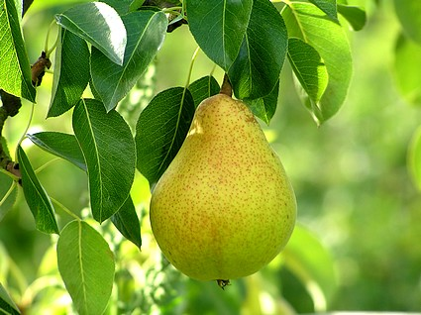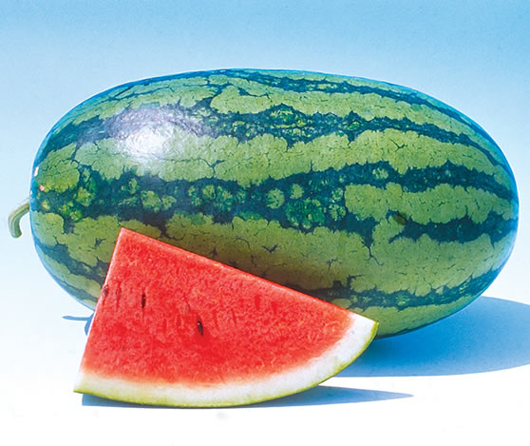Fruits

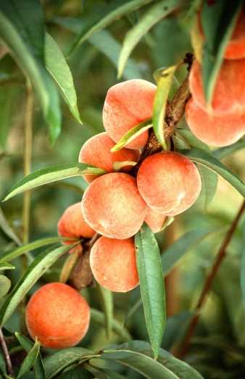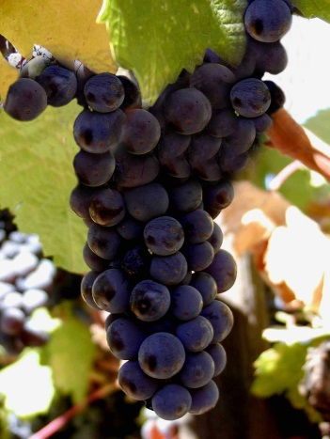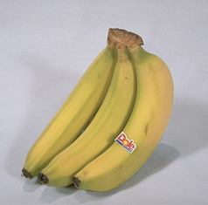

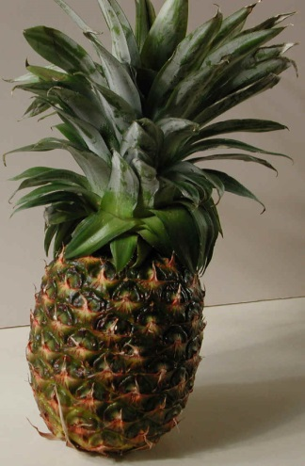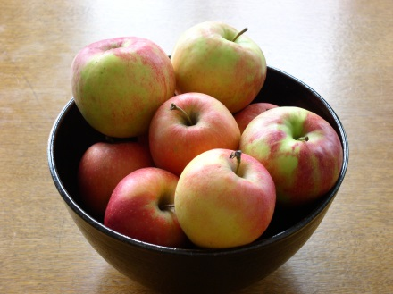

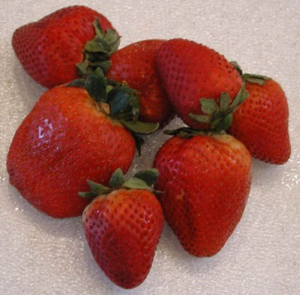

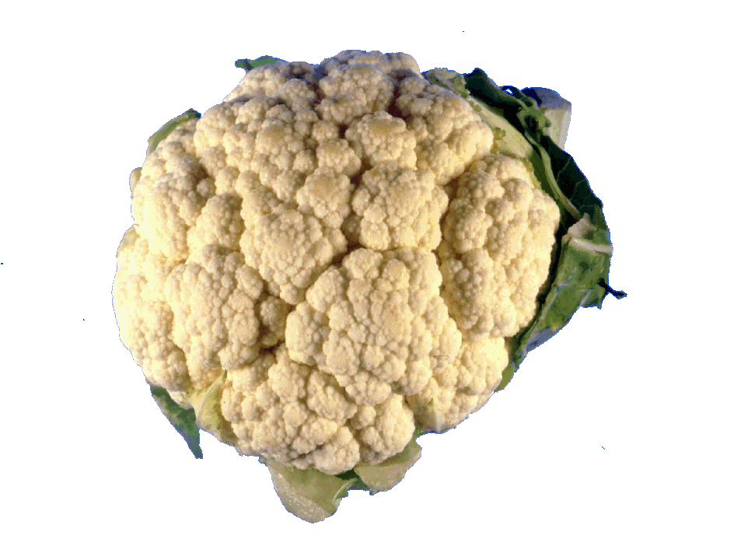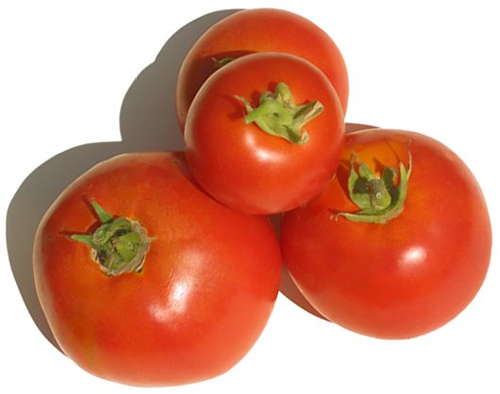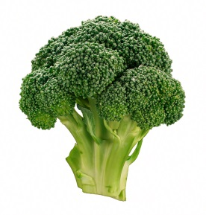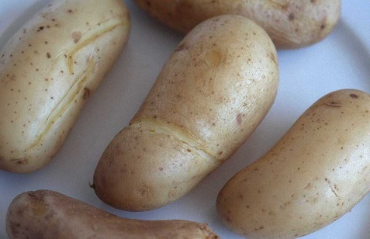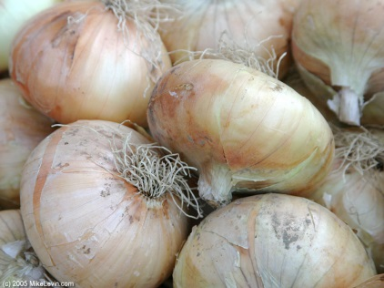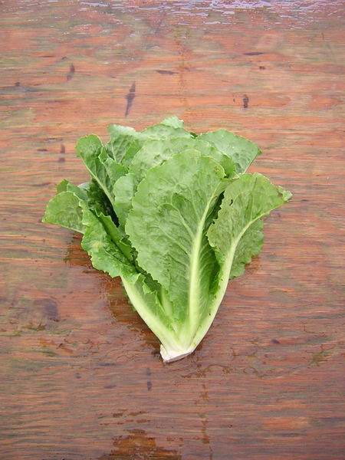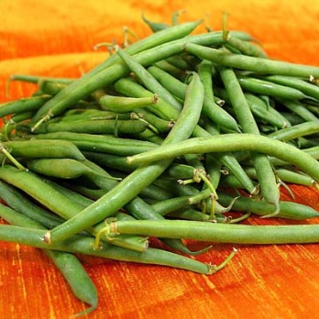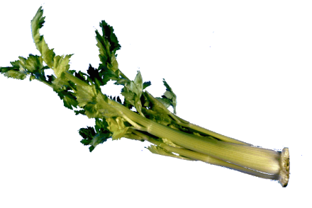Vegetables

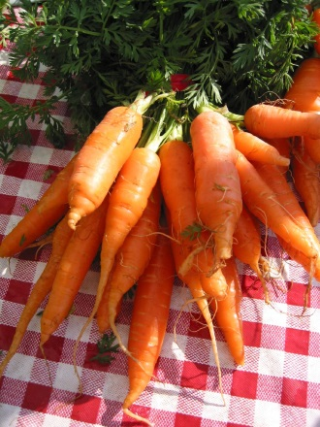

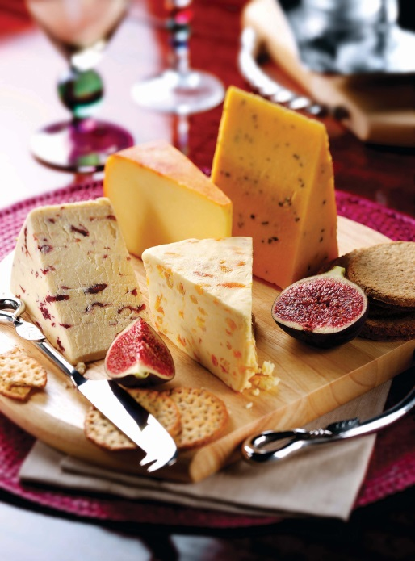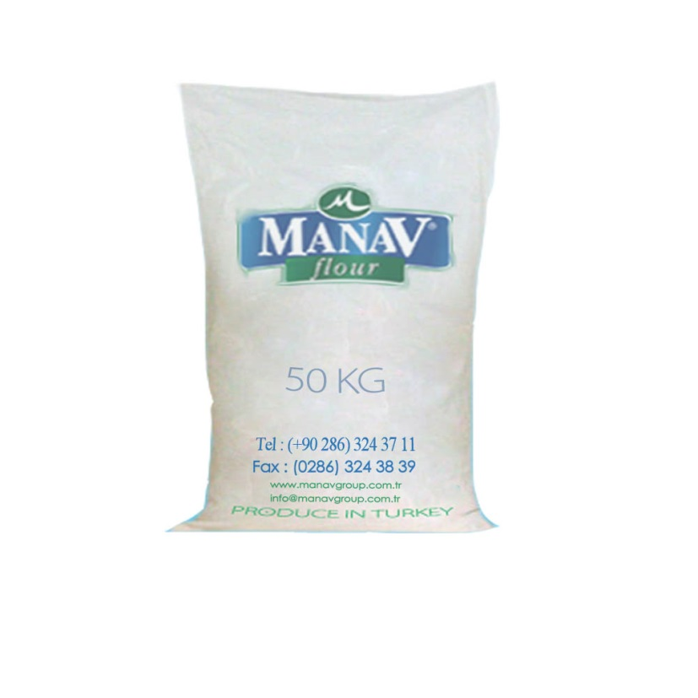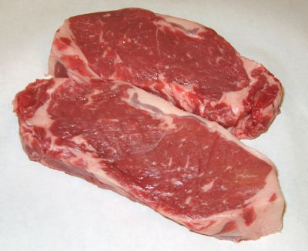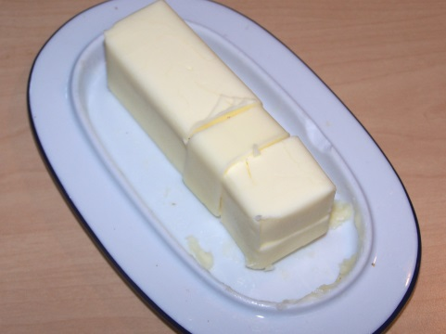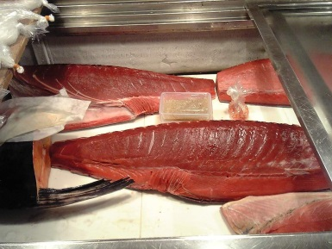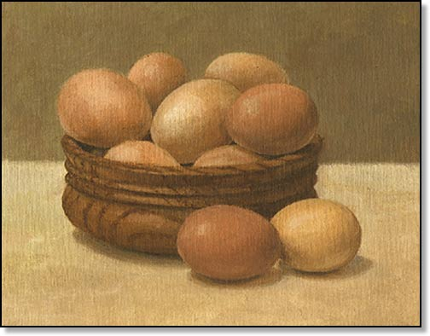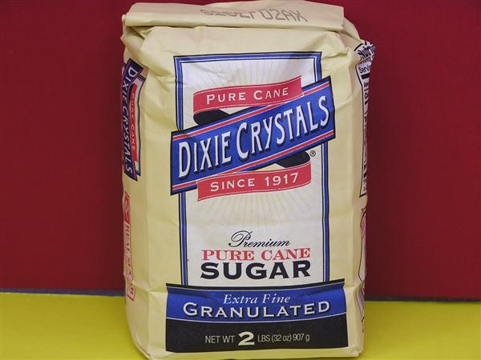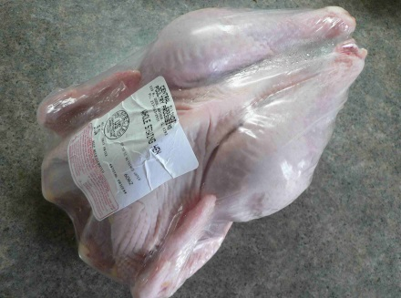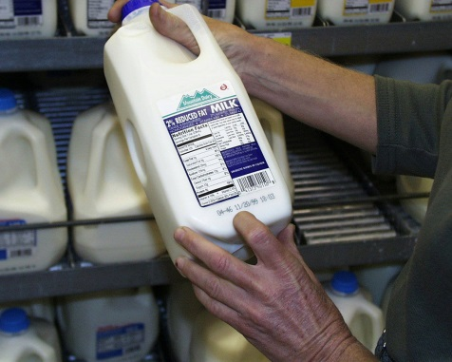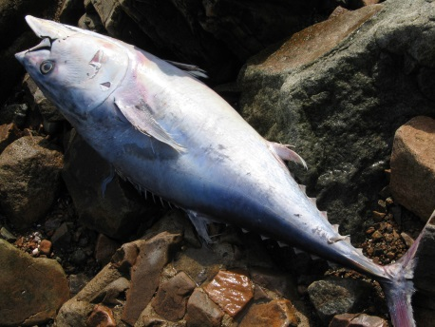Other Foods

Nutrition Labels

**From: http://www.kidshealth.org/kid/stay\_healthy/food/labels.html**You know how books have a table of contents that explains what's inside? Or maybe you've received a toy that came with a diagram that identified each small piece. Nutrition labels are sort of like that. They tell you what's inside the food you're eating and list its smaller parts.

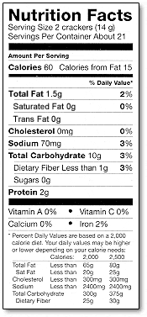The Nutrition Facts food label gives you information about which **nutrients** (say: **nu**-tree-ents) are in the food. Your body needs the right combination of nutrients, such as [vitamins](http://www.kidshealth.org/kid/stay_healthy/food/vitamin.html), to work properly and grow. The Nutrition Facts food label is printed somewhere on the outside of packaged food, and you usually don't have to look hard to find it. Fresh food that doesn't come prepackaged sometimes has nutrition facts, too.

Most nutrients are measured in **grams**, also written as **g**. Some nutrients are measured in **milligrams**, or **mg**. Milligrams are very tiny - there are one thousand milligrams in a gram. Other information on the label is given in **percentages**. These numbers are based on eating 2,000 calories in a day, the amount that many school-age kids eat . A [calorie](http://www.kidshealth.org/kid/stay_healthy/food/calorie.html) is a unit of energy, a way of expressing how much energy you would get by eating a certain food.

If you want to learn more about the different types of information on food labels, keep reading. We'll start at the top of the label and work our way down.

**Serving Size**

The nutrition label always lists a serving size, which is an amount of food, such as 1 cup of cereal, two cookies, or five pretzels. The nutrition label tells you how many nutrients are in that amount of food. Serving sizes also help people understand how much they're eating. If you ate 10 pretzels, that would be two servings.

**Servings per Container or Package**

The label also tells you how many servings are contained in that package of food. If there are 15 servings in a box of cookies and each serving is 2 cookies, then you have enough for all 30 kids in your class to have one cookie each. Math comes in handy with food labels!

**Calories and Calories From Fat**

The number of calories in a single serving of the food is listed on the left of the label. This number tells you the amount of energy in the food. People pay attention to calories because if you eat more calories than your body uses, you might gain weight.

Another important part of the label is the number of calories that come from fat. People check this because it's good to limit fat intake. The calories in a food can come from fat, protein, or carbohydrate.

**Percent Daily Value**

You'll see percentages on food labels that are based on recommended daily allowances - meaning the amount of something a person should get each day. For instance, there's a recommended daily allowance for fat, so the food label might say that one serving of this food meets 10% of the daily value. The daily values are based on an **adult's needs**, not a kids' needs. These are often similar, but kids need may need more or less of certain nutrients, depending on their age and size.

Some percent daily values are based on the amount of calories and energy a person needs. These include carbohydrates, proteins, and fat. Other percent daily values - like those for sodium, potassium, vitamins, and minerals - stay the same no matter how many calories a person eats.

**Total Fat**

The total fat is the number of fat grams contained in one serving of the food. Fat is an important nutrient that your body uses for growth and development, but you don't want to eat too much. The different kinds of fat, such as saturated, unsaturated, and trans fat, will be listed separately on the label.

**Cholesterol and Sodium**

These numbers tell you how much [cholesterol](http://www.kidshealth.org/kid/talk/qa/cholesterol.html) and sodium (salt) are in a single serving of the food. They are included on the label because some people need to limit cholesterol or salt in their diets. Cholesterol and sodium are usually measured in milligrams

**Total Carbohydrate**

This number tells you how many [carbohydrate](http://www.kidshealth.org/kid/stay_healthy/food/carb.html) grams are in one serving of food. Carbohydrates are your body's primary source of energy. This total is broken down into grams of sugar and grams of dietary fiber.

**Protein**

This number tells you how much [protein](http://www.kidshealth.org/kid/stay_healthy/body/protein.html) you get from a single serving of the food. Your body needs protein to build and repair essential parts of the body, such as muscles, blood, and organs. Protein is often measured in grams.

**Vitamin A and Vitamin C**

These list the amounts of vitamin A and vitamin C, two especially important vitamins, in a serving of the food. Each amount is given as a percent daily value. If a food provides 20% of the RDA for vitamin A, that one serving of food gives an adult one fifth of the vitamin A needed for the day.

**Calcium and Iron**

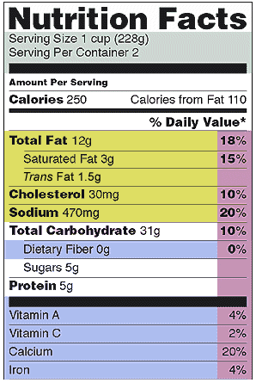These list the percentages of [calcium and iron](http://www.kidshealth.org/kid/stay_healthy/food/minerals.html), two especially important minerals, that are in a serving of the food. Again, each amount is given as a percent daily value. If a food has 4% of iron, you're getting 4% of the iron you need for the whole day from that serving.

**Calories per Gram**

These numbers show how many calories are in one gram of fat, carbohydrate, and protein. This information is the same for every food and is printed on the food label for reference.

Now that you know a little more about food labels, you can read up on what you're eating!

What food do you think the nutrition label at the right might be for?

**Buying Jeans at a Department Store**

*Read this dialogue about buying jeans in an American department store.*

Clerk: May I help you?

Customer: Yes, I’m looking for a pair of jeans.

Clerk: The jeans are over on the left side of the store.

Customer: Thank you.

(Customer looks through jeans, then takes 5 pairs to the fitting room.)

Fitting room attendant:

I’m sorry, you’re only allowed to take in 3 items at a time.

Customer: Oh, sorry.

(Customer tries on jeans.)

Customer to attendant:

I’ll take this pair.

Attendant: Just take them right up to check-out.

Customer: Okay. What do I do with these other pairs?

Attendant: You can hang those up on that rack over there.

Customer: Okay. Thanks.

*1. How is buying clothing in Indonesia the same? How is it different?*

*2. Is buying clothing different than buying other products in Indonesia?*

**American Money**

**Coins**

|  |  |  |  |  |
| --- | --- | --- | --- | --- |
| penny | penny | penny | penny | penny |
|  |  |  |  |  |
| penny | penny | penny | penny | penny |
|  |  |  |  |  |
| penny | penny | penny | penny | penny |
|  |  |  |  |  |
| nickel | nickel | nickel | nickel | nickel |
|  |  |  |  |  |
| nickel | nickel | nickel | nickel | nickel |
|  |  |  |  |  |
| dime | dime | dime | dime | dime |
|  |  |  |  |  |
| quarter | quarter | quarter | quarter | quarter |
|  |  |  |  |  |
| quarter | quarter | quarter | quarter | quarter |

**$1 Bills**

|  |  |
| --- | --- |
| bill_1 | bill_1 |

**$5 Bills**

|  |  |
| --- | --- |
| bill_5 | bill_5 |

**$10 Bills**

|  |  |
| --- | --- |
| bill_10 | bill_10 |

**$20 Bills**

|  |  |
| --- | --- |
| bill_20 | bill_20 |

**8. Responsibilities in a Community**

* **I can *discuss* civic responsibilities and *tell* about my involvement.**
* Brainstorm: What are civic duties? (or responsibilities)

Voting?

Supporting local businesses?

Giving food to the poor?

Volunteering at your child’s school?

* In small groups, have students tell about their involvements in their community.
* **I can *understand* and *fill out* an internet volunteer registration form.**
* Use the “Volunteer Match” form to give students experience in signing up to volunteer, and filling out an internet form.
* **I can *read* a story about volunteering, and take notes.**
* Have students read a story about volunteering.
* Have them take notes on what the volunteer in the article does.
* Have students share their notes with each other, and create an advertisement for this kind of volunteer work, including what qualities the volunteer should possess, and what he or she would be expected to do.
* **I can *read* about a volunteer opportunity.**
* **I can *write* a letter applying for the position, and answer questions in an interview.**
* Provide descriptions of volunteer opportunities.
* Have students choose one of the opportunities (or a different one) to apply for.
* Have students write letters to apply. In pairs, conduct interviews for the positions.
* **I can *compare* volunteering in the U.S. and Indonesia in a *discussion.***
* As a class or in small groups, discuss similarities and differences between volunteering in the U.S. and in Indonesia.
* **I can *give* a report about a local volunteer project, and *answer* questions.**
* Have each student prepare an oral report about a local volunteer project. Possible projects might include:

Helping the homeless

Teaching Sunday School

Volunteering in a literacy program

* Have students in the class ask follow-up questions for the reporter to answer.
* Encourage students to bring visual aids to explain the project.
* Encourage students to tell their conversation partners about their project.

|  |  |
| --- | --- |
|  | [VolunteerMatch](http://www.volunteermatch.org/) |
|

***Create a New Accountspacer.*** *Please complete the required fields\* below.*

Top of Form



|  |  |  |
| --- | --- | --- |
| First name \* |  |  |
| Last name \* |  |  |
| Email \* |  | [[Help](http://www.volunteermatch.org/help/glossary.html#email_address)] |
| Phone \* |  |  |
| Address 1 |  |  |
| Address 2 |  |  |
| Address 3 |  |  |
| City |  |  |
| State |  |  |
| Province |  |  |
| ZIP/Postal Code \* |  |  |
| Country \* |  |  |
|  |  |  |
| Terms & Conditions \* | I agree to the [Terms & Conditions](http://www.volunteermatch.org/legal/terms.jsp). |  |
|  | I am at least 16 years old or have my parent's permission to use VolunteerMatch. |  |
| Newsletter Subscription | Volunteer Newsletter & Special Messages | [[Help](http://www.volunteermatch.org/help/glossary.html#newsletter_signup_vol)] |
|  |  |  |
| New Password \* |  | [[Help](http://www.volunteermatch.org/help/glossary.html#password_plain)] |
| Confirm Password \* |  |  |
|  | Passwords must be at least four (4) characters long, and must not begin or end with spaces. |  |

Taken from: http://www.volunteermatch.org/

|  |  |
| --- | --- |
| |  | | --- | | [BBBS_271x80_National_Blk](http://www.bbbs.org/site/c.diJKKYPLJvH/b.1539751/k.BDB6/Home.htm) | |
| |  |  |  | | --- | --- | --- | | |  |  | | --- | --- | | |  | | --- | | **Big Brother Joe and Little Brother Ka'Mare at a 2006 World Series game in St. Louis."He's Always Waiting When I Get There.”**  Ka’Mare was a little shy at first. It isn’t always easy meeting someone new. But once he learned how much fun it was having Joe Clifford as his Big Brother, he started to open up. In fact, lately he’s started calling Joe each week — just to confirm the day and time Joe is coming!  And when Joe gets there, Ka’Mare is waiting on the step. He’s just so excited! Sometimes they go for pizza, or do homework together. Sometimes they toss a baseball, just like Joe used to do when he was a boy. Sometimes they play basketball, and once Joe took him on a trip to the science museum.  Then this fall they took another kind of trip … to the World Series!  Joe “stepped up to the plate” by becoming a Big Brother. He’s a role model, a mentor … and a friend! You can make a meaningful difference in the life of a young person by volunteering as a Big Brother or Sister, or by making a generous donation. | | | |

Adapted from: <http://www.bbbs.org/site/apps/nl/content.asp?c=diJKKYPLJvH&b=1755227&ct=3250927>

**Soup Kitchen Volunteer [Recommended agencies](javascript:openWindowNextToMouse('/util/medallion.tcl?medallion_id=3',%20350,%20200))**

|  |  |
| --- | --- |
| |  | | --- | | *Last updated on September 25, 2006* |   The Soup kitchen volunteer assists in the preparing, serving, and cleaning up of the meal that is served Monday through Friday between 11:00 A.M. and 12:15 P.M. The volunteers arrive between 8:00 - 9:00 A.M. and work directly with the Soup Kitchen cook. At 11:00 A.M. the kitchen opens to the public and the volunteer helps to welcome and serve the guests. At 12:15 the kitchen closes and volunteers and staff are invited to eat. Clean-up begins at 12:15 P.M. and is finished before 1:00 P.M. A kind and friendly attitude is an asset. It is also great if you know how to work around food |

Taken from: <http://www.volunteersolutions.org/pittsburgh/org/opp/228170.html>

**OPPORTUNITIES AVAILABLE FOR LIBRARY VOLUNTEERS**

**Homebound Volunteer**

Volunteer visits life care center residents and brings items from the Library. The Library staff provides training and support to the volunteer.  Time donated varies.

**Reading Buddies**

Teen volunteers are matched with younger children. They take turns reading to each other at the Library for short periods of time. This program is primarily active during the summer months.

**Home Borrowers Service**

Volunteer brings materials from the Library to a person who cannot leave his or her home due to illness, disability, or lack of transportation. A match is made between the volunteer and the receiver of the service based on geographic considerations and common interests. This service, on average, requires an hour two or three times a month.

Taken from: http://www.oceancountylibrary.org/Services/Volunteer.htm#OPPORTUNITIES%20AVAILABLE%20FOR%20VOLUNTEERS