9. House

HOME

1. Standby
If possible bring toy furniture to class. If not, use pictures. Spread them around the room and ask students to stand near each piece of furniture that you call. Students move around and you check if they have learned the new words.
Note: You can also do the same activity with school things.

2. Feel It
Put all the toy furniture in a bag. Let students touch the furniture inside the bag without seeing it. They have to guess what they are touching.
Notes: You can also do the same activity with school things.

3. Which is missing?
Spread the furniture on a table, ask students to close their eyes and remove one piece. Students have to ask which one is missing.
Notes: You can do this activity with any vocabulary you want to.

4. Rooms
Say the name of a room and ask students to write down all furniture that goes in this room. The student with most correct words is the winner.
Note: If your students cannot write the words, they can draw them.

KITCHEN

1. Different kitchens
Show pictures of different kitchens. Have students notice the main things in a Western kitchen: stove, refrigerator, sink, counter, microwave. Have them make statements about their own kitchens, such as:
- I don’t have a stove.
- I have a sink.
- My refrigerator is not in my kitchen.
2. Table settings
Bring in plates, cups, napkins and cutlery. Have students set the table how they do. Then, show them the table setting. Have them make statements about where various things are, such as:
- The spoon is on the right.
- There are two forks.
- The cup is at the top right.

3. Table setting relay
Divide the class into two teams, and set up for a relay race. The first person on each team will run to the front and properly organize a place setting. As he picks up each item to put it in the proper place, he must say its name… “knife” “spoon” “plate”, etc. He runs back and then the next person comes. The teacher must mix up the items again after each person takes their turn.

GAMES / ACTIVITIES
- Bingo: pictures and words

WORKSHEETS
- Reading: By the time students reach this point in Level 1, they should be able to do the following suggested activities associated with the reading “I Like My House.”

- Take students to visit my house. Talk informally. Let them ask questions. Talk about the furniture, rooms, etc.

- While there, take pictures of the students in various rooms in my house.

- Show pictures at the next class. Have students talk about the rooms and furniture, trying to remember the new words.

- Give reading: I like my house.

- Read while students follow along.

- Answer any questions about vocabulary.

- Have students read again silently, then answer the questions.

- Share answers in pairs, then discuss as a class.

- For homework, have students write about their own homes.

- Students bring in their writing. Teacher indicates corrections to be made.

- Students re-write, and submit again.

- Students bring in pictures of their home to go along with the story.

- The class publishes a booklet about all of their homes, with pictures and text.

I Like My House!

I live in Malang, on Tidar Street. I have a nice house. It is two stories. On the first floor, I have a living room and a dining room. My living room has a brown sofa and chairs. It also has a coffee table, an end table, a lamp, and a TV. My dining room has a buffet with lots of pictures of my family on top. I also have a big mirror, and a dining room table with six chairs.
My kitchen is also on the first floor. I love to cook in my kitchen! It has a black and white floor, and a round table in the middle. I have a microwave, a stove, a refrigerator, and a sink. My first floor also has my bedroom, our computer area, and a guest bedroom. I use the guest bedroom for my office.
What about the upstairs? My daughters live there, and it’s too messy to talk about!
Questions:
- What rooms are on the first floor?
- Where is it messy?
- Where is the mirror?
- Which room does Jan like most? Why?

In the house
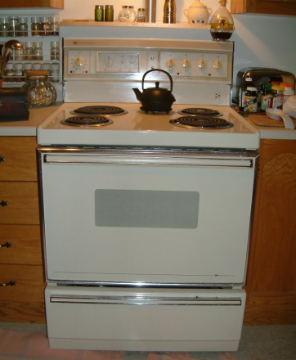
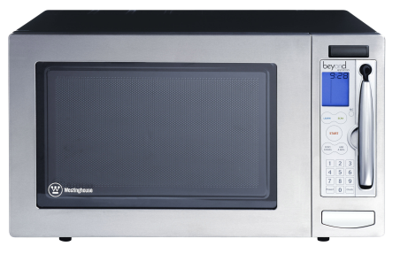

Microwave

Stove
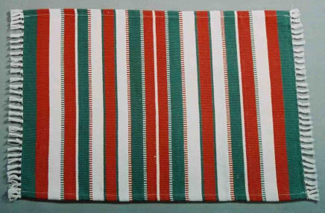

Refrigerator

Rug

Fan

Curtains

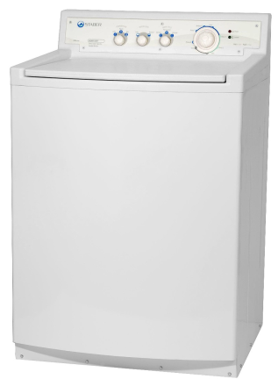
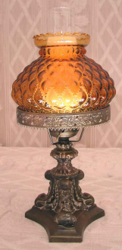

Television (TV) Lamp
Washing machine

How many do you have in your house?

Ask your friend: “How many ___________ do you have in your house?”
Answer: “I have _____ (number) __________ in my house.”

Friend’s
name
Beds
Dining
Tables
Dining
Chairs
Coffee Tables
End Tables
Living room Chairs
Sofas
Dressers
Closets
Bedside Tables
Lamps
Pictures
Plants
Doors
Book Shelves
TVs

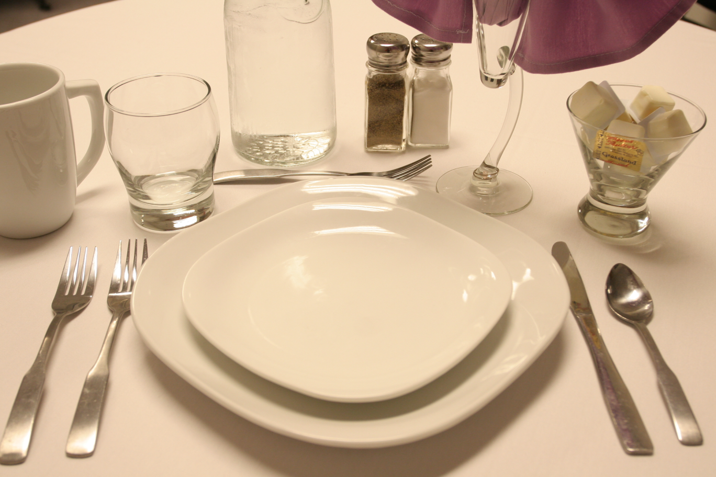
Table Setting

10. Body

BODY

This is a good sequence for teaching parts of the body:
- Do TPR, calling out various parts of the body, and having students touch that part.
- Provide the words for parts of the body on small cards, with tape on the back. Have someone come up to be the model. Have other students come up and put the words on the correct body part, “labeling” the volunteer.
- Provide similar cards for small groups of 4-5 students. Each group should choose a volunteer, “label” that person, then have the teacher check that all the words are in the right place.

1. Monster Draw
Bring a simple drawing or picture of a monster, but do not show it to students. Describe the monster and ask students to draw it. The monster most similar to yours is the winner.
Note: Students can draw their own monster and describe it to another student to draw it.

2. Simon Says
Play Simon says with the parts of the body.
Notes: Students can take turns giving the commands.

3. Silent Dictation
Point to any part of your body and ask students to write it down. This activity is a silent dictation and can be done with any vocabulary you want; you just need picture cards without words or realia.

4. Funny Bones
Have students work in pairs. Provide each pair with a card (3x5 or 4x). Randomly say two body parts, such as “ear to shoulder”. The pair must then touch one person’s ear to the other person’s shoulder, holding the card between them so it doesn’t fall. It is best if students work in same-sex pairs for this activity.

SONGS
- I See With My Eyes
- Head and Shoulders Knees and Toes
- Hokey Pokey

GAMES / ACTIVITIES
- Bingo: point to a part of your body, and students must find that word on the bingo form.
- Twister: A game using colors and hand/foot

WORKSHEETS

USEFUL GAMES AND ACTIVITES

1. TOTAL PHYSICAL RESPONSE (TPR)

This is simply giving commands to be followed. For example, the teacher says, “Touch your head” or “Turn on the light” and students respond. This method allows students to hear and understand the target language, without the frustration of having to speak.

2. CIRCLE PRACTICE

Students and teacher sit in a circle (usually on the floor). The teacher begins by speaking a word, phrase, or question to a student next to her. That student repeats it to the next student, and so on. Often an exchange can be practiced, such as the following:
T: This is an apple (handing the student an apple).
S1: What?
T: An apple.
S1: This is an apple.
S2: What?
S1: An apple.
S2: This is an apple
And the apple continues around the circle. If this activity is being used for review rather than for introducing new content, the teacher may start a second phrase after the first has been done by one or two students. For more fun (and confusion!) start another phrase going in the opposite direction around the circle!

3. LETTER SCRAMBLE

People of all ages love to solve puzzles. An easy type of language learning puzzle is the creation of words from letters provided. Provide small groups or pairs of students with letter cards to organize into words or short phrases. Or, simply put the letters on the board. By having several such activities in envelopes, groups can compete to see who can finish them all first!

Sample:

I L S G H E L O I V E N

4. SENTENCE SCRAMBLE

Begin with 8-10 sentences that are at the students’ level. For beginners, the sentences may be very simple, including only 4-5 words. Cut up the words and for each sentence and place them in envelopes. Students work in teams, doing the following:
- One person in each team runs up to the teacher’s desk, takes and envelope, and takes it back to his/her team.
- The team puts together the sentence, and has the teacher check it.
- They put the words back in the envelope, and return them to the front.
- They take another envelope, and repeat the task.
- The first team to finish all the sentences wins!

5. SEARCHING AROUND THE ROOM

Information on cards around the room is always more interesting than information given out by the teacher or in a textbook! Here are two variations of this activity:
- Have students find answers that go in blanks on their worksheets
- Give each student one card, and have him search the room to find the other (for example, matching a word and a picture).

6. TIC-TAC-TOE

Nearly any vocabulary words or structures can be practiced with this game. Create a tic-tac-toe grid, using the top for one set of words and the side for another. In teams, students place their X’s and O’s by creating appropriate sentences. See the examples below:

Example One:
Target language practice: subject/verb agreement; pronouns

 | he | we | I
go

take

like

Explanation:
- If a team wants the middle square, they must make a sentence combining “we” and “take”, such as, “We take the bus to school.”
- If a team wants the top right square, they must make a sentence combining “I” and “go”, such as, “I go to school every day.”

Example Two:

Target language practice: singular, plural, and uncountable nouns

 | apples | banana | milk
have

eat

like

7. BINGO

The game of Bingo provides excellent listening practice for language learners. In this game students listen for items on a 25-square grid. As they hear the teacher call out an item, they check that item off on their grid. When they have 5 checked in a row (up, down, or diagonal) they yell out “BINGO!” The first to get Bingo is the winner. However, you should keep playing until all of the items have been called out.

When using Bingo, keep in mind that students all need to have different bingo forms. In other words, if you are calling out numbers and students are finding the numbers on their forms, the number “7”, for example, would be in a different place on each student’s form. You can achieve these random forms in two ways:
- Provide students with random forms that you have created. This is a lot of work, but if you will use the forms again and again, it is worth it.
- Put a list of items to go in the squares on the board. Have students copy the items randomly onto squares on their Bingo forms.
- Provide students with small pieces of paper to place on their Bingo forms. These papers could be colors, numbers, or pictures. As you call out items, students remove the papers from their forms. When they have a whole row blank, they call out Bingo.

Some types of Bingo games for language learning are:
- Numbers: students hear a number called by the teacher, and must identify which number it is on their form.
- Similar words: students hear words spoken by the teacher, and must choose the correct word on their forms. (Ex: sit, set, men, man, three, tree)
- Pictures and words: students hear a word called by the teacher, and must find the picture on their form. OR, the teacher shows a picture, and students must find the word on their Bingo forms.

Keep in mind that Bingo is a language-learning activity only when students hear a word and must distinguish among items that that word could represent on their Bingo forms. Or, when students see a picture, and must distinguish among words on their Bingo forms that are the same as the picture. So, for example, if a teacher wants to use Bingo to practice “furniture” words, she could do this two ways:
- Have pictures on the Bingo forms, and say the words.
OR
- Have words on the Bingo forms, and show the pictures.
If the teacher has words on the forms, and calls out the words, this is not helping students learn the meanings of the words, because students could choose the correct words even without knowing what they mean.
Bingo!
_________________

8. MATCHING

Sets of matching cards are very useful in language practice. Some examples of matching cards are:
- Numbers and their word forms
- Pictures and words
- English word and Indonesian word (don’t use if pictures are an option)
- Synonyms (words with the same meaning)
- Antonyms (words with opposite meanings

Matching cards can be used in several ways:
- The game of Concentration: Cards are laid out, face down. Students take turns turning over two cards. If the two cards match, the student gets to keep them and take another turn. If they don’t match, he must put them back in the original place. The student with the most pairs at the end wins.
- Class drills: Students are given one set, while the teacher has the matches. The teacher holds up a card, or says it, and students must find the match.
- Individual, pair, or small group drill: Students put the matches together, and call the teacher to check when they are finished.
- Organizing students into pairs: Give each student a card. Have students find their matches. These two students then work together on another activity.

9. INTERESTING DRILLS

Repetition in language learning is important, but it can be boring if teachers don’t devise creative methods for practice. Here are some interesting repetition ideas:
- For children: Have students repeat words and phrases after you. However, vary your voice each time in the following ways: high voice, low voice, whisper, shouting, laughing voice, crying voice.
- Toss a stuffed animal or ball around the room. Whoever catches it must say the word or phrase, then throw it to someone else.
- Tell students to go around the room and say the word or phrase to as many people as they can in 30 seconds. See who can talk to the most people!

10. TWO-BOARD GAMES

In this version of board games, students move around two game boards, instead of one. On each game board they will land on a word. They then must combine these two words to make a sentence.

General Instructions

- Students play in groups of 4-5.

- Each group is given a dice, and each member has two identical markers (buttons work well).

- Students place one of their markers on the board that has a “start” place, and place the other one anywhere on the “circle” board.

- Students take turns rolling the dice, and moving the number of spaces indicated, on each board.

- Students then combine the two words or phrases to make a sentence.

11. SURVEYS

When students go around the room gathering information from their friends, they engage in a lot of fun language learning. Surveys can help students practice asking and answering questions. For lower level students, prompts should be given so that students will know how to ask the question, and how to formulate the answer.

12. INTERVIEWS

In an interview activity, students work in pairs to gather information about each other. Through this activity they get a lot of practice asking and answering questions. The interview data can then be used for writing or speaking activities.

13. UPSET THE FRUIT BASKET

This is a circle game that kids love, and adults often enjoy too. Have students sit in a circle, with one person in the middle. Everyone needs a name within a category. For example, if practicing months of the year, your “name” would be the month you were born. The person in the middle calls out one “name” within the category, and everyone with that “name” must move seats. In this example, the person in the middle would call out a month, and everyone born in that month would have to move. The object is for the person in the middle to also find a seat when others get up. There must be one less seat than people, so someone is always stuck in the middle as “it”. To make it more interesting, the person in the middle may call out two, three, or more names, or may yell out “upset the fruit basket” and everyone has to move!
Months, first letters, colors of clothing worn, or favorite foods could all be versions of the game that do not require that the teacher “assigns” names or words to students. But to practice other items such as numbers, colors, animals, foods, plants, professions – anything, the teacher simply goes around and whispers a “name” within each category, to each student. The teacher must also put all the names being used on the board. Then the game can begin.

14. DICTO-COMP

This combination of dictation and composition can be used successfully for older children and adults. It practices all four skills (reading, writing, speaking, and listening), and helps students develop accuracy in language use. All you need is a short (3-4 sentence) paragraph that is written at the students’ level, that is about something that is interesting to them. When you have your paragraph, follow these steps:

- Introduce the topic so that students will be prepared for the text. This could include asking questions, showing pictures, or introducing vocabulary words.
- Read the paragraph to the students. Do not allow them to write anything down.
- Read the paragraph again, allowing students to take notes. Repeat this step a few times, if necessary.
- Ask students to re-write the paragraph, based on their notes. Give them these guidelines:
  - Their writing should have the same ideas.
  - Their writing should be grammatically correct.
  - Their writing does not need to be exactly like the paragraph you read.
- In groups of 3-4, have students share their paragraphs, and come up with a group version.
- Students write their group versions on the board or on large poster board which can be put on the wall.
- The teacher reads each paragraph as it is completed, underlining parts that may need work. Groups gather around their versions, correcting them and soliciting the teacher’s help as needed.
- All groups read their paragraphs to the class.

SONGS

1. Head and Shoulders

Head and shoulders knees and toes, knees and toes
Head and shoulders knees and toes, knees and toes
Eyes and ears and mouth and nose
Head and shoulders knees and toes, knees and toes

2. Hokey Pokey

You put your right hand in, you put your right hand out
You put your right hand in and you shake it all about
You do the hokey pokey and you turn yourself around
That’s what it’s all about!

- left hand
- right foot
- left foot
- back side
- head
- whole self

3. It’s About Love

Love, love, love, that’s what it’s all about
‘Cause God loves us, we love each other
Mother, father, sister, brother, everybody sing and SHOUT!
‘Cause that’s what it’s all about, it’s about love, love, love

4. Rainbow

First Part:
Yellow and orange and red and green, purple and blue
Rainbow, rainbow

Second Part:
God made a rainbow in the sky
Beautiful, colorful, rainbow, rainbow

5. We Thank You

We thank you, thank you, thank you for the good, good food (4x)
We thank you… for the good, good food!
Second Part:
We thank you, we thank you, we thank you for the food
With fellowship and harmony we thank you!

6. The ABC Song

A B C D E F G, H I J K L M N O P, Q R S, T U V, W, X, Y and Z
These are the letters of the alphabet, sing it again, so you won’t forget.

7. Crazy Clothes

Crazy clothes, I love wearing crazy clothes
From my head, to my toes, I love crazy clothes!

Pink and purple polka dots on my hat
Brown and orange stripes on my pants
My shirt is blue with red and yellow flowers
And my socks are one red, one green, one blue

Got a silk shirt that’s dressy and neat
I wear it with flip-flops on my feet
Socks with the flip-flops, sweat pants too
What a great outfit, Whoop-de-doo!

8. I Choose to Follow

God created our bodies, He created our minds
We are unique, we are mankind
God made us free to follow or not
To obey His word, and all that He taught

I choose to follow, to follow my Lord (4 x)

9. Noah’s Animals

The animals went into the ark (3X)
And then God closed the door
The dog (bow wow) and the monkey
The cat (meow) and the bear
The cow (moo) and the elephant
And then the lion (ROAR!)
The horse (neigh) and the rabbit
The bird (tweet tweet) and the snake
The pig (oink) and the kangaroo
And then the lion (ROAR!)
10. When Is a Good Day?

When is a good day to praise the Lord? (2x)
Oh…. Monday is a good day, Tuesday is a good day
Wednesday is a good day too
Oh…. Thursday is a good day, Friday is a good day
Saturday and Sunday too!

11. The Month Song

January, February, March, April, May, June, July, August,
September, October, November, December
Those are the months of the year.

12. I Like Bananas

I like bananas, and mangoes are sweet
I like papaya, but nothing can beat
The sweet love of God (sweet, sweet, sweet, sweet love of God)

13. Peanut Butter (“em” = “them”)

Peanut, peanut butter (JELLY!) Peanut, peanut butter (JELLY!)

First you take the peanuts and you dig em, you dig em,
You dig em, dig em dig em
Then you crush em, you crush em, you crush em, crush em, crush em,
Then you spread em, you spread em, you spread em, spread em, spread em

Peanut, peanut butter (JELLY!) Peanut, peanut butter (JELLY!)

Next you take the berries and you pick em, you pick em,
Then you crush em, you crush em, you crush em, crush em, crush em,
Then you spread em, you spread em, you spread em, spread em, spread em

Peanut, peanut butter (JELLY!) Peanut, peanut butter (JELLY!)

Next you take the sandwich and you bite it, you bite it
You bite it bite it bite it
Then you chew it, you chew it, You chew it, chew it, chew it,
Then you swallow, you swallow, You swallow, swallow, swallow

Peanut, peanut butter (JELLY!) Peanut, peanut butter (JELLY!)

Mmmmm good!

14. Pop Goes the Popcorn!

Put the popcorn in the pot, put the lid on tight
Put it on the stove and wait…
POP goes the popcorn!

Pop, pop, pop, pop, POP goes the popcorn! (2 x)

15. God is Watching Over Me

Watching, watching, watching, watching…

God is watching over me, God is watching over me
Wherever I go, whatever I do
God is watching over me

- When I’m in school
- When I’m at church
- When I’m on a bus
- When I’m in a car
- When I’m in a space ship headed for Mars!

16. Twinkle, Twinkle Little Star

Twinkle, twinkle, little star, how I wonder what you are
Up above the world so high, like a diamond in the sky
Twinkle, twinkle, little star, how I wonder what you are

17. God is So Good

God is so good, God is so good
God is so good, He’s so good to me

18. Lean on Me

Lean on Me when you’re not strong
I´ll be your friend, I´ll help you carry on
For I know, it won´t be long, till I´m gonna need
Somebody to lean on

You just call on me brother when you need a hand
We all need somebody to lean on
I just might have a problem that you’ll understand
We all need somebody to lean on

19. Make New Friends

Make new friends, but keep the old
One is silver and the other gold

20. Love in Any Language

Love in any language, straight from the heart
Pulls us all together, never apart
And once we learn to speak it, all the world will hear
Love in any language, fluently spoken here

21. When I Wake Up

When I wake up, I say, “good morning, good morning”
When I wake up, I say, “good morning to YOU!”

After lunch time, I say, “good afternoon, good afternoon”
After lunch time, I say, “good afternoon to YOU!”

When the moon shines, I say, “good evening, good evening”
When the moon shines, I say, “good evening to YOU!”

When I go to bed, I say, “good night, good night”
When I go to bed, I say, “good night to YOU!”

22. The Number Song

One, two, three, four, five, six, seven, eight, nine, ten,
Eleven, twelve, thirteen, fourteen, fifteen, sixteen,
Seventeen, eighteen,
Nineteen, twenty, twenty-one, twenty-two, twenty-three,
Twenty-four, twenty-five,
Twenty-six, twenty-seven, twenty-eight, twenty-nine,
Thirty, and on and on!
(But we start with…)

23. The Days of the Week (to the tune of “Are You Sleeping”)

Monday, Tuesday, Wednesday, Thursday
Friday, Saturday
Then comes Sunday, then comes Sunday
Holiday! Holiday!

24. All Weather Friend

Why should I care if the sun doesn’t shine, Jesus is mine, all of the time
Why should I care if it’s cloudy and grey, Jesus is with me always

If it’s rainy, snowy, cold and dark
I still have God’s love in my heart…

25. I See With My Eyes (Tune: My God is so Big)

I see with my eyes, I touch with my fingers
I smell with the nose on my face (sniff, sniff)
I hear with my ears, I taste with my tongue
And I eat with my mouth and my teeth (yum, yum!)

I run with my feet, I clap with my hands
I jump way up high with my legs (so high!)

I see with my eyes, I touch with my fingers
I smell with the nose on my face (sniff, sniff)

CHANTS

HOW ARE YOU?
Hello, how are you?
I’m fine. How are you?
I’m fine. How’s Jan?
She’s fine.
How’s Rod?
He’s fine.
How are the girls?
They’re fine.
How’s the dog?
He’s sick!
Oh no!!!!

THE WEATHER CHANT
What is the weather like today?
It’s sunny today, It’s sunny today.
What is the temperature like today?
It’s hot today, It’s hot today.
What are you wearing….today?
I’m wearing my sunglasses, wearing my sunglasses.
Change to…
- Snowy, cold, boots/mittens/scarf
- Rainy, cold, raincoat

THAT’S WRONG!
A monkey is blue.
No it’s not! That’s wrong! A monkey is brown!
An elephant is small.
No it’s not! That’s wrong! An elephant is big!
A flower is ugly.
No it’s not! That’s wrong! A flower is pretty!
The sun is cold.
No it’s not! That’s wrong! The sun is hot!
God is love.
Yes He is! That’s right! God is LOVE!!!

PLEASE AND THANK YOU
Please come here. Please come here.
(come)
Thank you.
You’re welcome.
Please sit down. Please sit down.
(sit)
Thank you.
You’re welcome.
Please stand up. Please stand up.
(stand)
Thank you.
You’re welcome.
Please stop this. Please stop this.
Okay.
Thank you.
You’re Welcome!

GOING ON A LION HUNT

Sit in a circle. Pat hands on floor to simulate walking. Make other hand gestures as appropriate. Children repeat each line after the teacher says it.

Going on a lion hunt (children repeat)

Gonna catch a big one

I’m not afraid!

What’s that up ahead?

A tree!

A tall tree!

A big, tall tree!

Can’t go over it

Can’t go through it

Gotta go around it!

Around the tree

Repeat various times, with various obstacles, such as a river, a swamp, a bridge. Use different prepositions for the sections “Can’t go over it…”

To end:
What’s that noise?

A LION!

A BIG LION!

A BIG SCARY LION!

Repeat all of the obstacles in reverse, rushing back through the river, around the tree, etc. End:
I’m not afraid! Well, maybe just a little!

BRUSH YOUR TEETH!

When you wake up in the morning at a quarter to one,
And you just want to have a little fun

You brush your teeth!
(ch, ch ,ch….Make sound and motion of brushing teeth)
You brush your teeth!
(ch, ch ,ch….Make sound and motion of brushing teeth)
(Repeat after each “hour”)

When you wake up in the morning at a quarter to two,
And you just don’t know what else to do, you brush…

When you wake up in the morning at a quarter to three,
And you just want to have a little spree, you brush…

When you wake up in the morning at a quarter to four,
And you’ve just got to have a little more, you brush…

When you wake up in the morning at a quarter to five,
And you feel more dead than you do alive, you brush…

When you wake up in the morning at a quarter to six,
And you’ve just got to have another fix, you brush…

When you wake up in the morning at a quarter to seven,
And you just want to get a little closer to heaven, brush your…

When you wake up in the morning at a quarter to eight,

Ah oh! No more toothpaste!

